Reference Case for Estimating the Costs of Global Health Services and Interventions

Anna Vassall, Sedona Sweeney, James G. Kahn, Gabriela Gomez, Lori Bollinger, Elliot Marseille, Ben Herzel, Willyanne DeCormier Plosky, Lucy Cunnama, Edina Sinanovic, Sergio Bautista, GHCC Technical Advisory Group, GHCC Stakeholder Group, Kate Harris, Carol Levin

Contents
SECTION A INTRODUCTION A-1
Background A-2
Guide through the Reference Case A-4
Estimating the Cost of Health Interventions: An introduction A-8
Unit costs and cost functions A-10
Reference Case approach - Costing for purpose A-15
SECTION B THE REFERENCE CASE B-1
Defining the purpose of cost estimation B-2
1. Study Design B-4
Methodological Principle 1 – Defining the purpose B-1
Methodological Principle 2 – Defining perspective B-2
Methodological Principle 3 – Defining the type of cost B-3
Methodological Principle 4 – Clear definition of ‘units’ B-4
Methodological Principle 5 – Determining the appropriate time horizon and periods B-5
Example of the application of study design principles B-7
2. Resource use measurement B-8
Methodological Principle 6 – Scope of the costing B-9
Methodological Principle 7 – Measuring and allocating resource use B-11
Methodological Principle 8 – Sampling B-14
Methodological Principle 9 – Measuring ‘units’ of outputs B-16
Methodological Principle 10 – Timing of data collection B-18
Example of the application of resource use measurement principles B-20
3.Pricing and valuation B-21
Methodological Principle 11 – Sources of price data B-22
Methodological Principle 12 – Valuing capital inputs B-23
Methodological Principle 13 – Discount, inflation and conversion rates B-24
Methodological Principle 14 – Using shadow prices B-26
Example of the application of pricing and valuation principles B-28
4. Analyzing and presenting results B-29
Methodological Principle 15 – Exploring cost functions and heterogeneity B-30
Methodological Principle 16 – Dealing with uncertainty B-32
Methodological Principle 17 – Transparency B-33
SECTION C APPENDICES a
Appendix 1 - Glossary b
Appendix 2 – Principles and Methods reporting checklist d
Appendix 3 - Standardized TB unit costs j
Appendix 4 – Advisors and stakeholders aa
References cc

INTRODUCTION

Background

Estimates of the costs of implementing health interventions are required for informing a wide range of decisions in global health. Costs are used in economic evaluations, such as benefit-cost or cost-effectiveness analysis, and other economic analyses to inform priority setting. Cost interventions are also needed for financial planning and management, and the formulation of resource requirements and budgets. In addition, cost estimates can provide additional detail on how interventions are implemented, which can be useful for assessing the efficiency of service delivery.
Costs are typically estimated using a range of approaches and assumptions, often combining data obtained as part of research studies with data collected as part of routine program implementation. While numerous textbooks and guideline documents exist, analysts apply and interpret such guidance based on their prior training, professional experience, and context. However, there is no widely agreed-upon common guidance on principles, methods, and reporting standards specifically aimed at cost estimation across global health.
The variation in applying the methods and reporting of costs for global health interventions has long been recognized¹⁻³. This variation can have an impact on estimates of cost-effectiveness, which should be comparable across interventions^{4,5}. A review of economic evaluations in the Tufts Medical Center Cost-Effectiveness Analysis (CEA) Registry found a high level of variation in costing methods, although the review noted an improvement in consistency over time⁶. Differences in data collection methods and in the application of analytic methods, a general lack of comprehensiveness, and inconsistent compliance to existing guidance were all observed⁷. As a result, reviews of global health costs conclude that methodological heterogeneity and lack of transparency make it impossible to compare studies over setting and time⁸⁻¹¹, and several papers point to the need to develop standardized methods for cost estimation in global health¹².

Aims

The goal of the ‘Reference Case for Estimating the Costs of Global Health Services and Interventions’ is to improve the quality of cost estimates through improved consistency and transparency of methods, assumptions, and reporting. The Reference Case is a guide that helps ensure that the process of cost estimation is clearly conveyed and reflects best practices, so that those using cost data can interpret the findings properly and assess their quality (accuracy, precision, generalizability, and consistency). The Reference Case provides a practical framework for analysts to ensure that they consider how methods may influence estimates and thereby improve the interpretation and use of cost data.
The reference case approach has its origins in the field of economic evaluation. The first US Panel on Cost-Effectiveness in Health and Medicine (‘US Panel’) proposed the use of a reference case “to improve comparability of cost-effectiveness analyses designed to inform decision-making while allowing analysts the flexibility to design studies that answer issues specific to a particular problem or industry”. This concept has since been applied by the International Decision Support Initiative (iDSI) to economic evaluations in global health¹³ and was recently extended by the second US Panel¹⁴.
However, while these past guidelines include sections on costing, these sections focus primarily on reporting, and do not explicitly address the methods and processes behind cost estimation. Many countries do not yet provide routine data on costs, so primary data collection and estimation is required. Furthermore, cost data are required for more purposes than economic evaluation. This Reference Case should be complementary to the other Reference Cases, providing additional specification for those analysts who need to collect primary cost data.
The Reference Case presented here provides guidance on and encourages consistent adherence to core principles for evaluating intervention costs. The Reference Case structure adopts a “comply or justify” approach, which allows the analyst to adapt to the specific requirements of the costing exercise, but introduces the condition that judgments about methods choices are made explicitly and transparently. The principles are not intended to methodologically restrict or exclude novel methods to improve or expand cost estimation. Where methods are unclear or lack consensus, this Reference Case presents reasonable options for the analyst to consider, highlighting the strengths and weaknesses of each.
The Reference Case is designed to facilitate costing analyses, rather than adding onerous burdens on analysts. The Reference Case offers standards for the design, implementation, and reporting of cost estimates. It does not offer a comprehensive ‘how to’ guide, but we hope that the principles outlined here can inform the development of detailed costing manuals and tools, by our team and others. However, we do provide some tools, such as reporting tables, that can standardize and streamline the process of adopting the Reference Case principles.

Reference Case Guide

For whom is the Reference Case intended?

The Reference Case is intended for use by multiple constituencies, including policy makers, program managers and staff, health service managers and analysts who support them, working in national ministries, international donor and multilateral organizations, private foundations, research institutions, and non-governmental organizations. It is intended to provide an overview/reference document of costing methods that can be applied in different documents and tools to support costing, depending on the audience and purpose. It does not replace the need for these tools, such as intervention-specific costing manuals. The one ‘tool’ it does provide is reporting standards.
For those who fund cost estimation, the Reference Case provides a minimum standard that can help funders design Terms of Reference (ToR), including specific reporting requirements.
For those who use cost data, the Reference Case provides guidance that can be used to assess whether a cost estimate is ‘fit for purpose’. These users may be economic analysts, modelers, or financial experts in government and non-government organizations, who wish to use the data collected by others to conduct economic and financial analyses. These readers are also advised to focus on the introductory sections, and on the reporting matrix contained in Appendix 2 that provides quality indicators according to purpose.
For those who produce cost data, all sections of the Reference Case should be of interest, as a background reading into the main principles and methods behind costing studies. This is the primary target group for the Reference Case. However, the Reference Case does not provide a ‘how to’ manual for costing any specific health intervention; instead it provides the principles required for study design and methods development. The sections on methodological specifications provide detailed guidance to achieve best practice in cost estimation. The Reference Case can be used to design detailed tools and guidance for those leading the costing of specific services and interventions, but it does not include data collection or analysis tools. The GHCC website is expected to include selected examples of data collection and analysis tools that are ‘Reference Case compatible’ at https://ghcosting.org, in addition to both downloadable Word and HTML versions of the full Reference Case.

Structure of the Reference Case

In line with the IDSI Reference Case on economic evaluation, the technical content of the Reference Case (both costing and reporting) is presented by defining principles and methodological specifications. Principles provide a set of rules that are sufficiently broad to gain consensus and apply in multiple settings. While the application of principles may vary depending on the purpose of the costing, they should be universally applicable to any cost estimate.
Principles provide the conceptual framework for more specific methodological standards, where they are possible to define as they are supported either by evidence or theory. Principles also provide the basis for standardized cost reporting. Methodological specifications are a set of methods that enable the analyst to adhere to the principles. They may not be exhaustive, in that there may be other means to achieve the same principles. The methodological specifications presented here are a work in progress and will be further refined by the GHCC over the course of the project.
The Reference Case includes a reporting standards checklist, aligned to the principles, to support generalizability of cost estimates across settings and diseases. The final section provides additional specifics around the application of the Reference Case for all tuberculosis (TB) interventions and services.

The process of Reference Case development

The approach to developing the Reference Case was based on previous work developing reporting guidelines¹⁵. These outline the following stages of standards development.
Box 1 – Summary of the iDSI Reference Case guidance on cost

Principle

All differences between the intervention and the comparator in expected resource use and costs of delivery to the target population(s) should be incorporated into the evaluation.

Methods

Primacy should be placed on the transparency, reasonableness and reproducibility of cost estimates, so that different decision-makers can assess whether the results are generalizable to their jurisdictions.

Overall costs of interventions (excluding costs that do not vary across alternatives) should be reported as a key component of cost-effectiveness.

Where data are adequate, costs of resource inputs to deliver interventions and quantities of resources should be reported separately from their unit costs/prices.

All resource items involved in the direct delivery of health interventions should be costed because there will always be opportunity costs.

Economies of scale and scope may be important and should be incorporated when feasible. Caution should be applied when applying cost functions if these cannot be supported with reliable evidence.

Costs should be estimated so that they reflect the resource use and unit costs/prices that are anticipated when interventions are rolled out in real health care settings.

Costs should be reported in US dollars and in local currency. The date and source of the exchange rate used should be reported, as well as whether the exchange rate is unadjusted (real) or adjusted for purchasing power parity (PPP).

It is important to identify the need for a guideline and examine whether existing guidelines can be extended. While the purposes of costing go beyond economic evaluation alone, we decided to ‘extend’ the Reference Case developed by iDSI on economic evaluation. We did this for two reasons.
Firstly, costs are used for a range of purposes in addition to economic evaluation. Secondly, the Reference Case for economic evaluation does not provide guidance on cost data collection. While in some settings cost data used in economic evaluation are produced by routine systems, in many countries globally this is not the case, and analysts need to estimate costs using primary data collection. There is a wide range of tools available to do this, but no single comprehensive document that summarizes the ‘state of the art’ in the methods used to inform these costing tools.
The next stage is to review the literature to confirm the gap and to identify current evidence on methods. We conducted a bibliometric review (forthcoming) of methodological literature on global health costing. We then organized a meeting identifying participants through our networks, but also identifying authors from the bibliometric review. We conducted a survey among participants on the need for a Reference Case and current methodological gaps prior to the meeting.
The GHCC core team wrote the first draft of this Reference Case as an explanatory document. It was then circulated to a list of technical advisors and stakeholders for review. In November 2016, a meeting was held to discuss the Reference Case and receive feedback. During the meeting, a review of the current quality of cost estimates and a systematic review of the literature on costing methodology were presented. In the latter case, the review included both academic papers and current costing guidance for global health. The meeting did not use a formal method to reach consensus, but all participants were asked to comment on the principles and suggest amendments. All suggestions were considered. Small groups met to discuss methodological specifications. In this case, some of the suggestions were incorporated, but where there was no agreement on methods specified, further working groups were established and the guidance has been left open. The Reference Case was then sent for review to all meeting participants. A list of all who contributed is contained in Appendix 4, including those who provided detailed comments on earlier drafts of this document.
A publication and communication strategy will be developed to accompany the Reference Case. Both producers and users of cost data will also pilot the recommended guidance described in the Reference Case during 2017. The Reference Case will be made available on the GHCC website and updated as methods are further refined and developed.
Finally, it should be noted that several updates for the Reference Case have been identified and will be further developed later in 2017/2018. These topics were identified during the November 2016 meeting by participants. These are:

Sampling for cost estimation (principle 8)

Methods guidance on ‘within country’ cost functions (principle 15)

Methods guidance on how to identify the most important resource use to measure (principle 6)

The scope of the Reference Case

The Reference Case on global health costing provides guidance on estimating costs using primary data collection. Routine program monitoring systems, such as hospital cost accounting systems that estimate expenditures on specific procedures or diagnoses, can often provide useful information for costing analyses. As will be highlighted later in this document, such expenditure information may not be adequate for costing analyses. Where routine systems are used to estimate unit costs, the Reference Case can help assess the quality of the estimates produced, as the quality of routine systems can vary considerably¹⁶. The Reference Case can thus help determine whether additional data collection is required.
Currently, this Reference Case focuses on the costs of providing services. These can include items paid for by clients/patients. However, we do not include methods to estimate access costs (which can include direct expenses such as transportation, and opportunity costs from time spent accessing and receiving services), nor do we address the measurement of productivity losses from the symptoms of illness and/or death.
This Reference Case does not provide standards and methods for conducting secondary analyses, such as programmatic budgeting by individual organizations, investment cases required by certain funding organizations, or estimating global price tags for a specific health technology or package of interventions. The results of costing analyses are, however, often useful inputs for these other types of analyses.

Estimating the Cost of Health Interventions: An introduction

This Reference Case is intended to be used by both economists and non-economists. To assist, a glossary of terms related to cost estimation is included in Appendix 1. In some cases, economists use terminology in different ways. Where this is the case, we have described this and identified the way in which we have used the term in the Reference Case in the glossary. There are, however, some issues and concepts that are particularly important. We therefore highlight the concepts, definitions, and terminology that are most critical to understand when using the Reference Case.

What is meant by costing?

Throughout this document, we use the term “costing” as a short way to describe the estimation of cost of health interventions or services in a specific context (location, time period, population, and other details discussed in later sections). However, there are several different types of costs, and these are described below.

Economic and financial costs
Firstly, it is important to be clear on the difference between ‘economic’ and ‘financial’ unit costs. The principles and methods specified in the Reference Case state that different types of costs are appropriate for different purposes, and it is essential that the type of cost is reported.
Financial costs capture the resources that are ‘paid’ for. They are thus contingent on the extent to which payment is made for the resources used. In cases where resources are donated, they would not be included in financial costs. Thus, financial costs can be generalized only across settings with similar payment structures. Also, since all resources (even donated) are paid by someone, financial costing implies a specific payer perspective – i.e., the financial cost from the point of view of an identified person, program, or organization.
Financial costs can reflect what is planned to be spent (financial costs for budgeting) or what has been spent. Financial costs, however, are also distinct from expenditures in how they represent monies that have been spent. In any one year, financial costs represent the annual cost of capital inputs “smoothed out” across the years of use of that input, in contrast to ‘lumpy’ expenditures that record cost at the year of purchase of the capital input.
In some guidelines, the term fiscal cost is used. Fiscal cost is a specific term used to describe costs incurred by public institutions.
Economic costs aim to capture opportunity costs. The opportunity cost of a health intervention is defined as the value of the highest-value alternative health intervention opportunity forgone. Economic cost therefore aims to capture the full value forgone of all resources used. In well-functioning markets, the price of a resource reflects its opportunity costs. However, in reality prices may not reflect value, and in some cases no market price is available. For example, if in one setting volunteer time is donated, the financial costs of this time may be low, but the economic costs of the labor would consider market salary rates for the same labor.

What is meant by a ‘unit cost’?

Unit cost refers to the average cost of an intervention, service or output. The phrase ‘Unit cost’ is also sometimes used to describe the cost of a specific input, such as ‘cost per test kit’. For this Reference Case, the cost for a unit of a specific input or resource is referred as to the ‘cost of an input’ or ‘the price of an input’.
There are many different types of health interventions, services or outputs. Health service ‘outputs’ can differ from per person reached by a public health strategy, to per person on a course of treatment, and to delivering one consultation or diagnostic test. The term ‘unit cost’ can be used to define the average cost of any of these. However, to support comparability when standardizing unit costs, some further clarity is required for each intervention. Defining both the intervention and its outputs to be costed is complex, as there may be a range of hierarchical outputs, and therefore to provide clarity, we adopt the following terminology:

Intervention ‘unit’ cost | Average cost of an intervention (or strategy) (e.g., unit cost per person or episode of expanding TB treatment, or costs of peer education per person reached)
Direct service/  output ‘unit’ cost | Average cost per health service output/service delivered. This can be per person or per specific output/service (e.g., outpatient visit, diagnostic test, inpatient bed-day). In some cases, this may be the same as the intervention cost, but in other cases multiple services may combine to produce an intervention
Supporting service/output ‘unit’ cost | Average costs of supporting or ancillary services and outputs. This can be per output or per specific service (e.g., critical enablers) that support the delivery of health services (e.g., cost of information and education per person reached)
Activity cost | Cost for each action required to provide services (may also be expressed as a unit costs, e.g., per health worker trained, in some circumstances)
Resource use (sometimes referred to as Q’s) | The quantities of inputs/resources (labor, buildings, etc.) used to produce activities
Input cost (sometimes referred to as P’s) | Value of an input/resource (e.g., wage rate or amount paid for a test kit, or shadow price)

Not every costing will involve such complexity, and sometimes the analyst will need to concentrate on estimating the unit costs of services only or specific activities. However, it is important to note that ‘unit’ costs may be very different depending on whether they are reporting intervention, service- or activity-level costs, and thus present challenges for standardization and understanding for both users and producers of cost data. Appendix 3 demonstrates how these distinctions can be applied to standardize the reporting of unit costs of tuberculosis (TB) programs. Box 2 provides an example, and further examples related to TB are provided in Appendix 3.

Box 2 – Example of ‘unit’ cost typology applied to TB treatment adherence
The intervention includes an m-health approach, which has a cost, but also will increase the average length of TB treatment. Therefore, the intervention cost will include the additional ‘direct service’ unit costs of the increased treatment length, and the ‘support service’ cost of providing m-health follow-up for patients.
The cost of TB treatment will include estimating the ‘unit’ cost for ‘services’ such as outpatient visits, the costs of inputs such as drugs regimens, and then multiplying them by the quantities utilized. Likewise, the cost of m-health may involve estimating the ‘activity’ costs of training health workers that can then be multiplied by the number of persons trained. The cost of the activity may be composed of the estimates of the quantities (Q’s) and values (P’s) of each of the resources used in the training.
Input costs
Activity costs
Direct
and
ancillary
service
‘unit’ costs
Intervention ‘unit’
cost
Cost per person
treated
Cost per person
successfully
treated
Q*Cost per
person
receiving m
-
health
intervention
Unit costs
per health
worker
trained
Buildings
Materials
Personnel
Unit cost of
software
development
Q*Cost per
outpatient
visit
Q*Cost per
regimen
Unit cost of
drugs
transportation
per facility

Unit costs and cost functions

Unit (or average) costs represent the total cost of producing a service divided by a given level of unit of intervention, output or service. ‘Unit’ costs can be measured across a whole program or for a specific site. As intervention, service or output levels increase or decrease, average costs will change. Cost functions describe how cost is determined by input cost, the amount of resources used, and other factors that may modify these such as the scale of production, or other characteristics such as quality. Cost functions reflect underlying production functions that describe how the factors of production, or ‘inputs’, can be combined to produce services and interventions.
An average cost function describes how unit (or average) costs vary as the level of intervention/service increases. Average cost functions exhibit different shapes. In some circumstances, average costs stay constant for all levels of service and intervention provision. However, average costs often vary (sometimes non-linearly) as level of provision of intervention/ service increases. In the short term (referred to as the short run), the amount of some inputs used stays constant, or ‘fixed’, as the level of service provision increases. The determination of which costs are fixed is highly contextual, as the ‘fixity’ of a cost reflects the characteristics of inputs, preferences and constraints faced by managers. For example, in some settings staff costs are fixed as they are governed by overall public employment regulations and limits, while in other settings managers at a local level may be able to vary their staffing numbers at short notice by employing temporary staff. In some cases, costs may also stay constant over different levels of service production as they are ‘indivisible’ – for example, where a hospital needs a minimal level of investment in a ward, such as for a laboratory with certain equipment, even to start providing services. In this case, whether one patient or a high number of patients are seen, a large proportion of cost will remain fixed.
At low levels of production, fixed costs may be spread across a low number of services/outputs, and so the average cost is relatively high. As production increases, fixed costs are spread across more persons and average costs decrease.
There are other reasons why an average cost curve of providers may slope downwards, which may still apply in the ‘long run’ where the quantities of all inputs can be changed by managers, and all inputs and costs are ‘variable’. In the long run, as volumes of services increase, a downward slope of the U-shape cost curve may also occur. Relatively large volumes of service provision may enable improved service organization and ‘learning by doing’ within providers, resulting in a more efficient input mix. However, at very high levels of service provision, the production process may become challenging. For example, large hospitals may have such a complex service mix that they become difficult to manage, and average costs may start to rise, corresponding to the rising part of the ‘U’. Whether this happens in practice will depend on the specific service and how the management of services is organized.
Taking a national perspective, average costs may also change with the scale of population coverage. Initially programs may also benefit from decreasing unit costs as some costs, such as program management, are shared over increasing volumes of service provision. However, there may also be a level of volume at which average costs increase again, due to the complexity of large-scale program management. Larger programs may also have to deliver services through increasingly small providers (with higher costs than larger ones), as they reach more remote locations. Likewise, the average costs of supervision and drug supply may rise as programs aim to cover more difficult-to-reach groups.
Therefore, theoretically, many global health services and interventions are hypothesized to have a production process initially exhibiting ‘economies of scale’, where average costs decrease as sites and/or programs expand. At a certain level, average costs may also begin to increase or exhibit ‘dis-economies of scale’. However, the empirical evidence to support arguments of ‘economies of scale’ in health services remains weak and varies by service. Therefore, while both this Reference Case and the iDSI Reference Case recommend the use of cost functions where available, empirical validation is often required before deciding on a specific form of cost function. Where there is none, the use of a single unit cost is accepted for most costing purposes. Nevertheless, it is important that those who measure and report ‘unit costs’ understand that the cost they are observing may be only be a good estimate in the context of the scale that it is produced, and any inference drawn should reflect this. Moreover, if the cost is to be transferred to other settings, those reporting costs need to provide sufficient information on context, such as the levels of service production. For further explanation of the term economies of scale, please refer to the glossary.
A second critical issue that determines ‘average costs’ is the way in which unit cost of a service varies dependent on the other services it is delivered with. ‘Economies of scope’ exist where providers deliver services more cheaply where multiple services are delivered jointly. This efficiency gain can be due to improved sharing of ‘indivisible costs’ such as overheads, or, as with economies of scale, through aspects like joint learning (sharing clinical teaching services and provision is an example of this). As with ‘economies of scale’, while there is a strong intuitive case that the joint production of services may reduce the average cost of each service, empirical evidence of the extent of these gains for most global health interventions remains scarce.
Even if no economies of scope are assumed, the joint production of global health services often presents substantial practical challenges as the allocation of joint costs to different services may be required. The allocation of costs is covered in the guidance below, but will always remain difficult. Even if economies of scope are ignored, it is essential that those who measure costs of services that are produced jointly understand that the unit cost being measured may only be a good estimate of a specific combination of services, and any inference drawn should reflect this limitation. Reporting the extent to which the service being costed is integrated or produced jointly is also important.
At present, this Reference Case does not provide methods guidance on the estimation of cost functions, but the methods described in this Reference Case can be used to collect cost data in preparation for such analyses. Further guidance will be issued in this area in the next version of the Reference Case. Briefly, there are several methods to do this. Broadly there are econometric (statistical) methods and more mechanistic models. Statistical methods exploring economies of scale rely on collecting unit costs from a large sample of sites. Time-series data can be used, although rarely so in practice to date, and may better describe the short-run average cost curve (depending on the length of the time series). If services or outputs change over time, however, time-series data may be limited. Key issues in all cost function analyses are the functional form and how to incorporate aspects such as quality. Mechanistic methods rely on understanding the underlying production function, describing how different inputs are used and combining this with detailed cost data. It is anticipated that subsequent versions of the Reference Case will elaborate and make further recommendations on this topic.
* * * * *
In summary, unit costs are at least in part determined by the relationship between inputs and outputs, and may vary by both the level of output (or service provision) and the scope of service provision, both of which are likely to change over time. While in some cases the average cost function for a service or intervention can be characterized using a single unit cost value, in many cases it cannot. If average costs vary, costs at a single point in time, at a specific level of service provision, may have limited usefulness for planning new services and for many other programmatic uses of cost estimates. When referring to ‘unit cost’ estimation, this Reference Case aims to facilitate the estimation and measurement of ‘single’ unit costs; however, the methods used may also assist in providing the data to estimate average cost functions.

Incremental vs. marginal unit costs

Average or unit costs can include all the costs involved in producing a service compared to doing nothing, or the additional cost required to add or expand a service. In economic terms, the marginal cost is the cost of producing one (or small amounts) of an additional unit of output as service levels increase. Marginal costs capture how additional costs change as service levels increase one unit at a time. Marginal costs are also not necessarily constant as levels of service provision and interventions increase. As production increases, the marginal costs of producing one extra output or service often decreases depending on economies of scale, but may, in theory, also increase.
Incremental cost is the term used to describe the difference in cost between two or more interventions or programs, or to compare a change of scale or approach to an intervention to the current provision. Incremental costs are the correct costs to estimate for economic evaluations (see iDSI Reference Case) that always compare interventions.
While the terms marginal and incremental cost are sometimes used interchangeably, incremental cost is the broader term, and includes marginal cost. Both marginal and incremental (financial) costs will in part be dependent on the extent of fixed costs (in the short run). However, this is more complex in the case when estimating incremental (economic) costs for an economic evaluation. Here, any resource that has an opportunity cost (i.e., it can be used for another purpose) that is different between the intervention and any comparator, even if fixed, would be included. For example, if a new diagnostic requires more staff hours than the standard of care, these staff hours should be costed. Staff will have an opportunity cost that could have been used for another intervention, even if resource use is drawn from current staff downtime. For further discussion of this issue see principle 6.

Terminology around costing methods

Terminology to describe costing methods is currently used inconsistently in the literature, e.g., the use of ‘top-down’ vs ‘bottom-up’ costing, and of ‘gross’ vs ‘micro’ costing. These terms are sometimes used interchangeably, and in other cases are distinguished from one another.
Micro-costing focuses on a granular accounting of inputs, whereas gross costing considers only aggregate costs. A micro-costing disaggregates the costs of a specific output into the specific items consumed, such as nurse time and consumable supplies. A gross costing approach simply estimates all relevant costs, typically from program expenditure data, and divides by the associated outputs such as patient episodes. Gross costing may also be done using tariffs and fees¹⁷.
In contrast, ‘bottom-up’ or ‘top-down’ refers to the way in which each resource is allocated to the unit cost being estimated. ‘Top-down’ costing divides overall program cost or expenditures, often including those above the service level, by number of outputs to calculate unit cost, while bottom-up costing measures input quantities at the client or activity level. Gross costing is commonly done top-down.
Micro-costing usually has a bottom-up element, measuring both service and resource use directly at the patient level, but may allocate some resources using top-down methods (e.g., administrative overhead). A specific hybrid form of micro-costing is ‘activity-based costing’ or ‘time-based activity costing’. This is not consistently defined as ‘bottom-up’ or ‘top-down’ in the literature. In some cases, it describes a ‘top-down’ process using a set of rules that allocate overall expenditures firstly to activities and then to services¹⁸. In other reports, it is described as a bottom-up approach¹⁹, which assesses the actual amount of resources to produce each service, usually by identifying activities and the staff time spent, and allocating costs according to this staff time use.

Reference Case approach – Costing for purpose

What makes a ‘good’ cost estimate?

Fundamentally, costing is an estimation process. Any Reference Case therefore needs to be rooted in the scientific principle of what defines ‘good estimates’. However, as with any estimate, the extent to which cost estimates need to meet any quality criteria depends on the intended purpose for the estimates, which can be complex to define.
So, what is meant by a ‘good’ cost estimate? In statistical terms, the quality of an estimate can be defined along two dimensions:
Accuracy – This reflects the extent of systematic bias in an estimate (how far the estimate is from the true value of the population average cost), often referred to as internal validity. For example, an average cost estimate that systematically excludes overhead cost is biased downwards.
Precision – This reflects the narrowness of clustering of the measurement around the central estimate, such as the mean. For example, if a small sample is used to measure unit costs, then it may have a high margin of error.
These concepts are illustrated in the figure below²⁰.
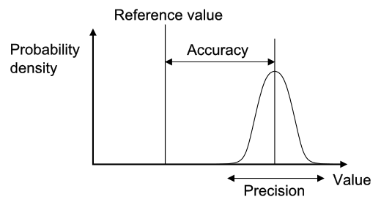
Clearly, greater precision and accuracy are both desirable. However, defining an agreed minimum level of precision and accuracy is problematic and relies on the purpose behind making the estimate. Unit costs may be used for a range of purposes from routine financial management to estimates of a ‘global price tag’ to scale up global health interventions (see the first section in the Reference Case below). These diverse purposes may require different degrees of precision and accuracy for different levels of aggregation (e.g., total vs. component costs). Moreover, costing itself can be expensive. The ‘cost of getting it wrong’ therefore needs to be weighed against the ‘cost of getting it right’.
There are some formal analytical techniques, such as the ‘expected value of perfect information’, that can help those considering how much to invest in improved cost estimates for specific purposes such as economic evaluation²¹. However, these analyses are expensive and time consuming in themselves, and are thus not widely applied. Given the wide range of purposes and the lack of formal approaches available, there remains no simple way to define ‘a universal minimum standard of precision and accuracy’ for cost estimation in global health.
There are two other important characteristics of cost estimates that may be relevant for specific uses. The first US Panel stated that a core rationale for Reference Cases is to facilitate the comparison of the results of different studies, so that “each study contributes to a pool of information about the broad allocation of resources as well as to the specific questions it was designed to address”¹⁴. This aim is particularly important in global health costing, where resources to collect data are scarce. Thus, three other properties of cost estimation that the Reference Case aims to facilitate are:
Generalizability – the extent to which the cost estimate can be directly applied to other programmatic settings (often referred to as external validity)
Transferability – the extent to which the cost estimate (with adjustments) may be transferred to other programmatic settings
Comparability – the extent to which the features (for example the perspective and the resources included) of one cost estimate are similar to one another
Unlike precision and accuracy, achieving generalizability may not be universally desirable. In some situations, the benefits of arriving at an accurate and precise context-specific estimate (internal validity) may override the benefits of a less precise but more generalizable estimate (external validity). Comparability, narrowly defined as an identical estimation process, may also not always be desirable for the same reasons as generalizability. However, comparability is less problematic, if it reflects improved transparency that permits analysts to adjust estimates in order to compare. So in summary, while generalizability is desirable in most circumstances, as with precision and accuracy, it is hard to set minimum standards in this respect without examining the intended use of the cost estimate. Comparability may, however, be improved simply through improved reporting, without adverse consequences.
In addition, any estimation method should be reliable. Ideally, if carried out by different people it should give consistent results. Likewise, if the estimate is carried out over time results should be consistent. Finally, there should be consistency if carried out across different health interventions, services or outputs.
The focus of a Reference Case therefore is not to set specific minimum standards for each of these characteristics of a ‘good’ cost estimate, but instead to define the ‘best methodological practice’ to support a cost estimation process that is fit for purpose and efficient given the funding and data available. It concentrates on providing a framework for analysts to structure their choices around study design and methods, and to consider how their methods influence the quality of their estimates so they can make efficient choices given their resources available to conduct the cost estimation. In doing so, it aims to improve both the precision and the accuracy of estimate for the funding available.
The Reference Case is more prescriptive, however, in terms of setting minimum reporting standards to improve the transparency of cost estimation. While it does not recommend specific methods to be used, it provides standardized ‘units’ and ‘results tables’, in addition to a methods checklist, to improve the comparability, transferability and generalizability of cost estimates going forward.

THE REFERENCE CASE

Defining the purpose of cost estimation

The starting point for the Reference Case is to define the different purposes for which cost estimates are used. Ideally, any cost estimate could be used for multiple purposes (accepting that some adjustments may need to be made). In principle, the use of high-quality cost data can result in the improved allocation of resources to global health strategies, interventions, and services that maximize health gain and financial risk protection. Improved cost data can also result in cost savings and efficiency improvements that ultimately can be used to fund additional health improvement-related activities. Moreover, if cost data are used to inform the equity of financing (and costs) between different payers, then ultimately good cost data can be part of reducing any negative poverty impact associated with ill health.
In practice, budgets for cost estimation projects are often set with a specific purpose in mind, and the methodological choices will be driven by that purpose. Each of these purposes may require different approaches to definition and measurement (e.g., the scope, frequency, and unit of the cost reported), and there may be different emphases in areas such as sampling. We have, therefore, indicated throughout the Reference Case where principles may apply differently depending on purpose. The starting point is to define the purposes. For simplicity, four ‘buckets’ of purposes are defined:
- Economic evaluation and/or priority setting

This purpose is defined as the use of cost estimates in analytical approaches to assess allocative efficiency (see glossary) of investment and policy decisions. These include, for example, cost-effectiveness analysis, cost-benefit analysis, health technology assessment, essential package definition, benefits package definition, etc. It may also include investment cases, linking closely to the estimation of resource requirements as below.
Comparisons of the cost-effectiveness of alternative uses of resources are now recognized as a core piece of information in decisions around whether to invest in new technologies, or set priorities across different strategies and interventions. For example, cost data are often critical in shaping the design of health care benefit packages provided by governments or insurers and, as many low-income countries move towards national insurance schemes, are needed to estimate reimbursement levels.
- Medium- and long-term financial planning and resource requirements estimation

This purpose describes the use of cost estimates to predict expenditures in the medium (3 to 5 years) and longer term. Examples include using costs to inform budget impact analyses, support medium-term expenditure frameworks, inform budgets for national strategic plans, develop financial plans for investment cases, and produce ‘global price tags’. These analyses both support national planning but can be used in both national and global fundraising efforts for increased investment in a specific global health area. For example, since 2009, the South African government has collected cost data to predict the medium- and long-term costs to the South African national public sector antiretroviral treatment (ART) program, which was then used to advocate for increasing funding for ARTs of funding.

- Budgeting and price-setting

Cost data may be of use to those planning both the incomes and expenditures of health providers (or funders). This purpose describes the use of costs to predict expenditures by specific budget holders and set prices for specific services. Budget settings would include annual program budgeting by managers for routine health services, or a specific provider, or could refer to an investment case for a specific project or a funding application. For some organizations, such as insurance companies or private providers, budgets involve planning incomes, and prices for specific goods and services for the coming year and costs are core element in this process.
4. Technical efficiency analyses
This purpose describes the use of costs to explore differences and drivers of technical efficiency (see glossary) between providers and/or modes of delivery (integrated services, platforms, level of decentralization, etc.) for health interventions or services, usually conducted through the comparison or analysis of costs over multiple sites, or by comparing estimate costs to benchmarks. Cost data from studies that help to estimate technical efficiency provide critical information for improving the value for money on the supply side, such as identifying the minimum efficient scale of operation, or providing insights into areas of efficient or inefficient practices. For example, WHO, UNICEF, and GAVI use unit cost data to identify and design efficient supply chain logistic systems in immunization.
For each of these purposes, there may be different theoretical and practical reasons why a certain type of cost or methodological approach is preferred. For example, where countries are moving towards universal health coverage, the need to generate reimbursement rates and to understand the comparative value of new technologies (i.e., applying economic evaluation/and or priority setting) creates a demand for unit cost data that are comparable across diseases and health services, follow a standardized methodology, and reflect economic cost.
In contrast, cost data for technical efficiency studies may need larger sample sizes, have a different perspective, and need additional information about cost determinants collected to enable analysis. For the purposes of financial planning and resource requirement estimates, financial costs are generally needed rather than economic costs, and disaggregation of prices and quantities in unit cost reporting is helpful; in the South Africa example above disaggregated estimates were used to estimate the impact of changes such as introducing task-shifting to lower staff cadres and opening the South African antiretroviral drug market to international competition.
Where recommended methodological approaches differ by cost purpose, these differences are explained in the Reference Case and illustrated throughout using two examples of costing exercises. The first example is based on an economic evaluation of condom distribution using community health workers in India, the Avahan program. The second example is based on an exercise to help the South African Government to plan roll-out of the Xpert MTB/RIF diagnostic for tuberculosis. These are only two examples and should be interpreted as illustrations, rather than any prescription of methods.
The Reference Case is composed of a total of 17 methodological principles across four main topics: (1) study design; (2) resource use measurement; (3) pricing and valuation; and (4) analyzing and presenting results. For each principle, we provide an explanation as to why it is important, and information on the methods specification below.

1. Study Design

Once the purpose has been determined, this section outlines the five principles and methodological specifications relevant for study design. The various steps/choices to be made when designing a cost estimation are outlined in the diagram below. A summary of the principles to be applied in each step is also provided in Table 1. Table 1 also includes guidance on how study design may be influenced by the purpose of study and the availability of data. A statement of each principle and its methodological specifications follows the summary table.
Table 1– Study Design ‒ Statement of Principles and Guidance by Purpose
 |  | Economic evaluation | Financial planning | Budgeting | Efficiency analysis
Study design
1 | The purpose, the population, and the intervention and service/output of the cost estimation should be defined. | All | All | All | All
2 | The perspective of the cost estimation should be defined. | Societal or provider | Provider or payer | Payer | Provider
3 | The type of unit cost estimated should be defined in terms of economic versus financial, real world versus normative best practice and full versus incremental cost, and whether the cost is net of future cost savings. The type of cost should be justified relevant to purpose. | Economic cost  Incremental cost  Real world  Net of future cost savings | Financial cost  Real world or guideline | Financial cost  Real world or guideline | Financial or economic cost  Real world
4 | The ‘units’ in the unit costs for strategies, services, and interventions should be defined, relevant for the costing purpose, and generalizable. | All | All | All | All
5 | The time horizon should be clearly stated and of sufficient length to capture all costs relevant to intervention and purpose, and consideration should be given to disaggregating costs into separate time periods where they vary over time. | To capture all costs | Length of financial plan | One budget cycle (usually one year) | Minimum one year

Methodological Principle 1 – Defining the purpose

The principle

The purpose, the population, and the intervention and/or service/output of the cost estimation should be defined.

Why is defining the purpose and intervention important?

As outlined in the introduction of the Reference Case, cost estimates may be used for multiple purposes, and the characteristics of a ‘sufficient estimate’ will vary accordingly. For example, an economic evaluation may require an incremental economic cost, while financial planning may require a financial cost from a specific payer’s perspective. If a cost estimate is used for the wrong purpose, or if its limitations are not described, it can be misleading. Therefore, it is important to be clear on the purpose for which the cost estimate is intended.
The requirement that the population and intervention and/or service/outputs be clearly described complies with standard economic evaluation guidelines, such as the US Panel recommendations and the iDSI Reference Case¹⁴. This information is essential for costs to be used appropriately and generalized to other settings, and provides the basis for determining the methods used for measurement.

Method specification

The introduction of the Reference Case provides examples of purposes that may be used. These are: economic evaluation, efficiency analyses, financial planning, and budgeting. The purpose should also identify both the relevance for health practice and policy decisions and the intended user(s) of the cost estimate, if known.
Ideally the intervention and/or service/output should be defined within context describing:
- Main activities/technologies involved
- Target population
- Coverage level or phase (pilot, implementation, post scale-up)
- Delivery mechanism (health system level/facility types/community/ownership /integration with other services where relevant)
- Epidemiological context (incidence/prevalence of the illness being addressed)

The comprehensive production process of an intervention and/or service/output (i.e., the activities, plus key technologies) should be outlined in the first instance, and if any parts of process are excluded (for example above service delivery activities) these exclusions should be clearly reported.

Methodological Principle 2 – Defining perspective

The principle

The perspective of the cost estimation should be defined.

Why is defining the perspective of the cost estimate important?

Once a purpose and user of the cost estimate is defined, it is important to address the perspective of the estimation. The perspective describes which payers’ costs are included in the estimate. Some users, who make decisions on behalf of a population, may need to use a societal perspective that captures all costs incurred by an intervention, regardless of who pays the costs. For other analyses, a more limited perspective may be taken. For example, to set a budget, it may only be important to estimate the costs that fall on a specific payer.
The requirement that the perspective should be described complies with standard economic evaluation guidelines, such as the US Panel¹⁴ recommendations and the iDSI Reference Case¹³. There are increasing calls for economic evaluations to adopt a societal perspective, including the recent recommendation by the Second US Panel to report two Reference Cases, one from a provider and one from a broader societal perspective²².

Method specification

Most textbooks in costing and economic evaluation categorize perspective into two types: societal and provider. However, in practice, these terms are used to describe a multitude of payers. For example, a provider perspective may include costs incurred by health service providers and non-health service providers, and be limited to specific payers. A societal perspective may also include client costs to access a service, costs to the household, costs to community, and in some cases even costs to the macro-economy or other sectors. Where clients or patients pay for services, the costs of provision may include a partial societal perspective. Therefore, a simple category stating the perspective as societal or provider is insufficient to generalize or compare costs. It is therefore recommended that a ‘stopping rule’ be defined and made explicit. A ‘stopping rule’ defines and explains which costs are included, and how the line is drawn between inclusions and exclusions.
The methodological specification is therefore to define perspective as societal or provider, but in addition to justifying and listing the groups/payers whose cost has been captured in the estimate. For a provider perspective, this should specify whether both health and non-health providers are included. For a societal perspective, this should specify whether it is cost to the client only, or more broadly to the household, community, or society.

Methodological Principle 3 – Defining the type of cost

The principle

The type of cost being estimated should be defined, in terms of economic versus financial, real world vs. guideline, incremental vs. full cost, and whether or not the cost is net of future savings. The type of cost should be justified relevant to purpose.

Why is defining the type of cost estimate important?

For different purposes, different types of costs are required. For example, economic evaluation requires an incremental economic cost to ensure opportunity cost is appropriately estimated¹³. Conversely technical efficiency analyses may be interested in examining the full cost, to identify any possible resource use that is inefficient. Different types of costs will require different measurement methods, and for reasons of measurement design and comparability, it is important to begin any cost estimation process with a clear definition of what cost is being estimated.

Method specification

There are four characteristics that must be defined. First is the distinction between economic and financial cost (see introductory text and glossary). Whether the cost is economic or financial will dictate which resources should be included and how they should be valued.
The next issue is whether the aim is to estimate the cost of an intervention conducted according to ‘normative best practice’, or whether the aim is to provide a cost estimate that reflects the costs of implementing an intervention in the ‘real world’ (which may include inefficiencies or exclude intervention components). Normative best practice may be described in guidelines, but guidelines may be out of date and expert consultation may be used. In most cases, this will also be a mixed picture, not a dichotomy, with some aspects of the ‘real world’ being included, but not all. For example, normative best practice may be defined as ideal norms, or have more realistic elements.
The setting where costs are collected may be pivotal. For example, where costs are collected in research settings they may be gathered from clinical trials or more pragmatic settings. Costs for economic evaluation are often collected from clinical trial sites, where the cost may include activities to ensure adherence to a guideline, which may also contribute to the effect size used in the incremental cost-effectiveness ratio (ICER) estimation. In this case is important to be clear that the costs include activities to ensure guideline adherence. It is therefore necessary to provide more detail than simply stating whether the cost is real world or based on guidelines. Given the complexity involved, transparency around this issue is particularly important.
It is also important to clarify whether the cost estimate is incremental to any comparator or a standard of care. The definition of incremental is outlined above in the introductory section. Further guidance on defining resources to be included in cost estimates is provided in methodological specification six below.
Finally, many global health interventions are preventative, and therefore it is important to report whether costs are net of future cost savings for health providers and households or just the costs of the immediate intervention.

Methodological Principle 4 – Clear definition of ‘units’

The principle

The ‘units’ in the unit costs for strategies, services, and interventions should be defined, relevant for the costing purpose and generalizable.

Why is using clearly defined and standardized units important?

A critical challenge in transferring and synthesizing cost estimates in the past has been the lack of standardized ‘units’ costs for interventions, episodes of care, and service use. This lack of standardization has created difficulty in assessing efficiency across settings, made past and existing efforts to conduct systematic reviews problematic, and impeded the creation of global datasets of costs that can be used to extrapolate costs to settings where data is currently absent. A key aim of this Reference Case is to address this gap by developing a standardized set of units for different disease and intervention areas.

Method specification

The introduction section above describes the categories of unit costs that may be defined (strategies, intervention and service units). As part of this Reference Case we also provide examples of standardized units for TB, based on the ‘units’ of strategies, services, and interventions that countries are reporting activity on globally, in Appendix 2. There is also guidance available in other areas, such as immunization, often developed in conjunction with global agencies working in specific areas. These can be found on the GHCC website: https://ghcosting.org/
In all cases these units should be reported, although in some circumstances it may be relevant to report additional units. For new interventions, or interventions with new components, other units may need to be developed beyond the standardized unit costs in this Reference Case. In some cases, the management information systems that report on the various ‘units’ will not align with the standard definitions; if this is the case, effort should be taken to collect the necessary additional data to adjust this reporting, or clearly explain any bias in terms of standardized reporting units.
Finally, a critical issue to consider is the use of quality-adjusted ‘units’. This is particularly the case for purposes that are examining efficiency. Comparing costs of services that are of varying quality and thus different is misleading. To explore efficiency, analyses may therefore want to examine the factors that influence the cost of services reaching a similar quality. For example, the purpose of the costing may require that the cost per person completing treatment, rather than the cost per treatment month, is explored. In other cases, the analysis may also consider quality as a determinant of costs. Even if not formally analyses, in all cases, efficiency analyses should consider the quality of the output, in any inference made from these analyses.
For other purposes, quality may be less critical to explore. For example, in cost-effectiveness analysis, the main metric is cost per outcome, and thus a decision may require also knowing the cost per quality adjusted output. For financial planning and budgeting, ideally the quality of the service being budgeted for should be clearly defined as part of the intervention definition, and ‘unit’ costs then measured accordingly.

Methodological Principle 5 – Determining the appropriate time horizon and periods

The principle

The time horizon should be explicit and of sufficient length to capture costs relevant to the purpose, and consideration should be given to disaggregating costs into separate time periods where they vary over time.

Why is specifying time horizon and time periods important?

Time horizon refers to the length of time of service provision or intervention implementation that the costs are being considered. While most unit costs are contained by the length of time it takes to provide the service or produce an output (for example, TB treatment is six months), there are other considerations depending on what costs are being estimated and the purpose of the analysis.
In economic evaluation, it may be necessary to estimate a unit cost of an intervention per person (see box 2 above). In this case the time horizon may have to capture multiple services over time. The iDSI Reference Case for Economic Evaluation¹⁴ states that time horizon used in an economic evaluation needs to be carefully considered because any decision made at a point in time will have intervention benefits and resource use extending into the future. An economic evaluation should therefore use a time horizon that is long enough to capture all costs and effects relevant to the program or policy decision. Economic evaluation Reference Cases and guidance more generally emphasize that the time horizon should not be limited by the availability of empirical data. In some cases, however, it is not possible to measure future costs and economic evaluations may include imputation of data that are incomplete or missing²³, with a number of analytical methods being available to address the specific issue of censored data²⁴. Other uses of cost data may have more circumscribed time horizons related to financial planning periods.
Finally, where estimating a unit cost for new services, it may make sense to disaggregate unit costs into different time periods. Costs may change during different phases of an intervention, and therefore an average unit cost over the entire intervention may have limited use for other analysts using cost data for specific phases of activities, particularly in financial planning. For example, costs may be different during the development of intervention, compared to implementation.

Method specification

For costs estimated for economic evaluations the time horizon should follow the methodological specifications in the iDSI Reference Case¹³. For other purposes, the time horizon should follow the planning cycle, (e.g., medium-term financial planning typically estimates costs for 3- to 5-year periods, while longer-term efforts to estimate resource needs to reach global targets may project costs for a 10- to 15-year period).
For interventions that are being piloted or at the early stages of implementation, costs should be disaggregated into those in a ‘start-up’ phase and those in an ‘implementation’ phase, at a minimum, with the start-up phase being treated as a capital investment (see principle 12 below). A start-up phase is defined as all costs incurred before the first service is delivered. For clinical services, like TB treatment or ART treatment, there may also be clinically related phases, such as intensive and continuation phases. Even within phases of treatment costs may vary, and it may be relevant to examine this in some circumstances. For example, hospital admission costs vary over the course of treatment (the first few days are often higher cost)²⁵. For an economic evaluation comparing an intervention reducing length of stay, it may be necessary to capture this variation over days.

Example of the application of study design principles
Example #1: Estimating the cost-effectiveness of HIV prevention in India (Avahan)
PRINCIPLE 2 - The perspective of the cost estimation should be stated and justified relevant to purpose.
PRINCIPLE 3 - The type of cost estimated should be defined and justified relevant to purpose
PRINCIPLE 4 - The ‘units’ in the unit costs should be defined, relevant for the costing purpose, and generalizable.
PRINCIPLE 5 - The time horizon should be of sufficient length to capture all costs relevant for purpose
PRINCIPLE 1 - The purpose of the study, population, and intervention and/or service should be clearly defined.
Economic evaluation
Efficiency analysis
Financial planning
Budgeting
Societal perspective
Provider perspective
Payer perspective
Financial cost
Economic cost
Net of future costs
Real world costs
Guideline costs
Incremental costs
Full costs
Intermediate outcomes
Units of coverage
Service use / outputs
Capture all relevant costs
Minimum one year
Length of financial plan
One budget cycle
What perspective should I take?
What type of cost should I estimate?
What units should I cost?
What time horizon should I use?
What is the purpose of the study?
Economic Evaluation - Cost-effectiveness analysis of HIV prevention in India
A societal perspective, and estimate all costs and benefits incurred by providers and by clients
We estimate the economic cost
We estimate a gross cost, due to the numbers of sites
We estimate the real world costs of implementation
We evaluate the incremental costs
Costs per person reached (as community intervention)
Four-year time frame to capture start-up until full coverage
Example #2: Planning scale-up of Xpert for TB diagnosis in South Africa
What perspective should I take?
What type of cost should I estimate?
What units should I cost?
What time horizon should I use?
What is the purpose of the study?
Financial planning of the government of South Africa for roll-out of Xpert MTB/RIF across the country
Cost data were collected from the payer perspective to help the National Health Laboratory Service (NHLS)
Financial cost data was collected to reflect anticipated expenditures by the NHLS
We estimate a micro-cost as there was good record-keeping
We estimate the full costs of Xpert as additional funding required varied by site
Costs per test
Costs were estimated for the length of financial plan, over two years
We estimate the real world costs as best predictor of expenditures

2. Resource use measurement

The second part of the Reference Case focuses on resource use measurement, and the methods used to capture the quantities of resources used to provide an intervention and/or service/output. Five principles are defined, represented in Table 2 and in the figure at the end of the section.
Table 2
Service and resource use measurement |  | Economic Evaluation | Financial Planning | Budgeting | Efficiency  analyses
6 | The scope of the inputs to include in the cost estimation should be defined and justified relevant to purpose. Where inputs are excluded for pragmatic reasons these should be reported. | Incremental costs estimated between alternatives; analysis can address omissions or uncertainty | Depending on purpose and timeframe | All inputs for the relevant budget holder | All inputs identified in the production process being analyzed
7 | The methods for estimating the quantities of inputs should be described, including methods, data sources and criteria for allocating shared costs, and the exclusion of research costs. | All | All | All | All
8 | The sampling frame, method and size should be determined by the precision demanded by the costing purpose and designed to minimize bias. | All | May require costs collected for different types of service providers | Sampling frame for sites/patients funded by specific payer only | May consider sample sizes that establish significance of specific cost determinants
9 | The selection of the data source and methods for estimating ‘units’ for unit costs should be described, with potential biases reported in the study limitations. | All | All | All | All
10 | Consideration should be given to the timing of data collection to minimize recall bias and, where relevant, the impact of seasonality and other differences over time. | All | All | All | All

Methodological Principle 6 – Scope of the costing

The principle

The scope of the inputs to include in the cost estimation should be defined and justified and relevant to purpose. Where inputs are excluded for pragmatic reasons these should be explicitly reported.

Why is defining the scope of the study important?

Being transparent and justifying the scope of the cost estimate in terms of which inputs are included is critical for comparability and can allow others to determine bias. The risk of bias from excluding components of cost (e.g., program administration, a personnel category, or off-site support) leading to inappropriate conclusions from costing studies is well recognized and one of the core challenges in cost estimation²⁶.

Method specification

The list of inputs to be included in the cost estimate will, in the first instance, be defined by purpose, perspective, timeframe and type of cost being estimated. For example, inputs such as volunteer time may be omitted where only financial costs are relevant (see principle 14 below). However, additional omissions may also occur as analysts balance the cost of data collection with potential bias from omitted inputs. While omission of items may be a practical necessity where expenditure or other records are not available on certain costs, it is essential that any deviation between the ideal scope according to purpose made, due to lack of data availability, is reported ‒ so that bias can be ascertained.

There is a range of methodological guidance that can be used to comprehensively identify the inputs associated with an intervention and/or service/output. These commonly build from a description of the production process (principle 1 above). Both providers and patients can be involved, and there are formal methods that may be employed to map the full range of resource use associated with production²⁷. In the first instance, analysts should use these tools to identify important inputs. In addition, in some cases, analysts may know of the cost structure from prior studies and can make informed judgments as to where primary data collection is most beneficial. Many studies also first pilot data collection instruments in a few sites to determine data availability and improve their understanding of the time and cost required to collect data on different inputs. All of these practices are recommended where feasible.
Where economic costs are estimated, it is essential that all costs are considered, excluding those that do not change between interventions. Resources that are sunk or not currently used to full capacity should be considered as incurring opportunity costs, if they can be used for other services. For example, if a new diagnostic requires more staff time compared to an existing diagnostic, the cost of this additional staff time should be included, irrespective of whether current staff are fully utilized. The same applies for shared resources such as management information systems. If the capacity of the shared resource used by the new intervention is also flexible enough to use for other purposes, then it has an opportunity cost. The extent of flexibility will be context and resource specific.
There are also some resources that are commonly excluded on arbitrary grounds, and should not be. Recent reviews of studies²⁸ where above service delivery costs have been included demonstrate that these costs can form a substantial part of intervention costs and yet are often not considered. “Above (delivery) site” activities include various support services provided by the central administration (e.g., Ministry of Heath) such as training, education and outreach, demand generation campaigns and central laboratory services. Most cost studies exclude these costs, or where they do include them, use inconsistent measurement methods. It is recommended that these costs should be considered in the same way as on-site costs, rather than arbitrarily omitted. Having said this, accessing data on above service costs can be a challenge. If a measurement process can’t be feasibly implemented then the omission should still be clearly stated, and any bias reported.
A further area that warrants specific mention is the costs of supporting change. The costs of many interventions are estimated for rapid and substantial scale-up in low- and middle-income countries, and the associated costs of implementing change may also be important. Examples include the costs of changing guidance on drugs regimens, providing health systems strengthening to enable managers to reorganize services, or production of health workers to support scale-up of interventions. Some analysts may also choose to include the costs of intervention development, while some consider these as sunk costs. These inputs should be included where relevant.
Where costs are estimated for economic evaluation or long-term financial planning, there is currently no consensus on whether future costs should be included, nor is there strong evidence of their importance, so they may be omitted. Nevertheless, analysts should state (if the costing includes future costs) whether unrelated costs are omitted as well as any methods for projecting future costs, and discuss any resulting bias in their projections or results. For analyses seeking to include future costs, it may be advisable to include both the health care costs directly related and unrelated to the specific condition being addressed by the intervention. For example, when working out the costs of a program that keeps those persons with TB or HIV alive, analysts may wish to consider the costs of treating any future illness²⁹.
Finally, when estimating incremental costs, determining the scope of the additional cost of the intervention to the comparator can be challenging³⁰. There is no consensus methodological recommendation in this area. However, studies that compare different methods, for example statistical methods or the use of mechanistic cost models to estimate costs attributable to both the comparator and the intervention, find that the method chosen influences results^{31,32}. In low- and middle-income settings, an important consideration is the extent to which the intervention and any comparators can be absorbed within existing under-capacity within the health system. If analysts adjust costs to consider spare capacity in the health system, they are therefore recommended to report any assumptions about existing capacity when describing the scope of ‘incremental’ cost.

Methodological Principle 7 – Measuring and allocating resource use

The principle

The methods for estimating the quantities of inputs should be described, including data sources, criteria for allocating shared costs, and exclusion of research costs.

Why is describing the resource measurement methods important?

The methods used to estimate the levels of inputs used in an intervention can bias estimates, and therefore should be reported. Broadly, analysts can select either a gross- or micro-costing approach, or a combination of both. Gross costing is defined as a process by which input use is estimated in total, and micro-costing where the analyst aims to estimate the usage of each input separately. In general, micro-costing tends to be more comprehensive and capture more input usage, with studies that compare micro- and gross costs finding that gross estimates tend to underestimate costs³³.
In the introductory material in this Reference Case it is highlighted that allocating costs between intervention is a challenge, and where the data is available it may be advisable to estimate total costs and derived incremental or marginal costs using econometric methods. However, in most circumstances, analysts need to design an allocation method for joint costs. The choice of using bottom-up or top-down allocation methods has also been shown to affect both the cost estimate and its applicability. While gross costing is done top-down (usually total costs divided by service unit levels), micro-costing may use both approaches to allocating resources. Bottom-up methods use approaches such as observation to estimate levels of input usage for a service, whereas top-down methods focus on allocating out the total amount of inputs used in facility, ward or clinic between services. Differences in cost estimates using bottom-up compared to top-down approaches are due both to measurement issues³⁴ and to differences in the included inputs³⁵. Top-down methods may capture some inputs where resource use cannot be observed due to demand or seasonal factors, for example, electricity. Top-down methods may also better capture inefficiency or down time and wastage. In comparison, bottom-up approaches allow for more understanding of individual service provision and may better characterize variation in practice³⁶. They may also identify inputs that would be missed in a top-down allocation of costs, by improving the analysts’ understanding of the production process.
In addition, there is increasing evidence that above service and overhead costs, which may have been conventionally allocated using simple ‘top-down’ techniques, may require more complex allocation approaches, given the substantial proportion of these costs for some global health interventions³⁷. The choice of allocation methods may also be particularly important when costing hospital care³⁸. One option to improve accuracy is to use techniques such as step-down methods³⁹ or activity-based costing. These methods first assign costs to departments and/or activities; costs at the departmental and/or activity level are then assigned to services. This step-down approach is recommended by some rather than using person-hours directly working on the service as typically done in micro-costing ⁴⁰⁻⁴². In some cases, it may also be possible to use regression methods and matched comparisons to identify costs for a particular service, where total costs are available for sites (and patients) with and without the intervention^{43,44}.
Human resources often make up the largest proportion of cost of global health interventions. Yet, health professionals, including community health workers, are often working in different services such as clinic and outreach settings. Measuring the human resources spent on an intervention is therefore one of the most important and challenging aspects of cost estimation and can substantially influence results.
Finally, a further important issue is the allocation of costs between research settings and real-world interventions. Many cost estimates for novel interventions are conducted in trial or demonstration settings. There is an extensive literature highlighting the limitations of using cost estimates from these settings to model the costs of intervention implementation in the ‘real world’. While many cost estimates carefully remove research costs, the difference between ‘research’ and ‘implementation’ costs can be hard to define. Those conducting cost estimates will need to make judgments/obtain information about how the intervention is likely to be implemented in the real world, for instance, whether or not an activity will be implemented, the frequency of activities, and the type of inputs – e.g., human resources – and include this in their assumptions. For example, activities such as ‘routine monitoring’ may change substantially if the intervention were scaled up.
Moreover, it may be easy to remove items such as survey costs but harder to determine the costs of any adjustments made to the intervention design for research purposes. For example, trials commonly need to conduct additional activities to ensure protocol adherence or to reduce loss to follow up. Thus, the intervention cost during a trial may create a distorted estimate⁴⁵. Even where these activities can be distinguished, research site selection may be biased⁴⁶ and have different levels of efficiency than other sites. In some cases, costs can be adjusted to reflect real-world inefficiencies⁴⁷. Finally, researchers can use input prices for inputs that will be used in real life rather than input prices in the trial. For instance, rather than use researcher/trial implementer salaries, they could use public sector health-worker salaries or average health-worker prices to reflect the likely costs on scale-up.
It should be noted that although the removal of research costs is desirable for some purposes, there are exceptions. In the case of economic evaluation, the effect size observed (and then used in the incremental cost-effectiveness ratio) may in part be due to research-driven activities. If these costs were removed, then this would change and bias the incremental cost-effectiveness ratio. Whether or not analysts choose to include research costs in their estimates, clear disaggregation between research and non-research costs should be regarded as a minimum standard.

Method specification

While micro-costing is seen as a gold standard by some, we do not recommend it in this Reference Case as a minimum methodological specification. In many cases, the required level of disaggregation for levels of use by input may be unnecessarily onerous, or gross costs may be available from routine systems that have already been validated. Micro-costs are, however, particularly useful in situations where costs may need to be disaggregated and routine systems are weak. Moreover, the disaggregation of cost components allows for adaptation of costs to other settings and can assist the assessment of heterogeneity across patient groups⁴⁸.
In practice, many analysts use a mixed-methods approach. For example, a recent guideline for disease-specific costing, which was applied in Nigeria, combines micro-costing for some elements with more feasible gross costs for others⁴⁹. Given the burden of data collection and the need to capture all resource use, bottom-up measurement may not be required for all inputs. Those cost components that have the greatest impact on costs (labor and inpatient stay) may warrant more accurate allocation methods⁵⁰. Analysts should therefore state the allocation method used for each input, including clearly describing if these are ‘top-down’ or ‘bottom-up’.
In all cases, the methods/criteria used to allocate shared resources should reflect usage of each input and should be explicit. Where allocations have been made ‘top-down’, either to sites or within sites to services, or above service delivery or overhead costs have been allocated, the criteria used and the relevant data sources of the allocation factors should be explained. The bias inherent in any data source used to allocate input usage should aim to reduce bias. For example, recall by medical staff of time spent on intervention activities may be accurate when the intervention occurs in large regular blocks, such as every Tuesday morning. However, staff recall may be unreliable when the intervention activity is interspersed with other responsibilities in irregular ways. In such instances, an appropriate contemporaneous recording of activities using “time and motion” or work sampling methods may provide more precise data^{51,52}. There is mixed evidence as to whether this sort of continuous observation may also influence behavior, leading to biased measurement^{53,54}.
More specifically, careful attention should be paid to methods used to allocate human resource costs. Several methods are commonly employed to estimate time spent on a service or interventions. These include focus group discussions, interviews with providers or patients, examining patient records, time sheets, direct observation of practice, and work sampling. There is no ‘gold standard’ as each of these methods has biases. Several of the methods are subject to ‘self-reporting’ or ‘observer’ bias that may result in more ‘desirable’ behavior. All methods may be subject to incompleteness. Approaches relying on patient records or reporting may not fully capture non-contact time (such as management and supervision costs), whereas approaches relying on self-reporting may be overly burdensome and may be under-reported in busy periods.
Where costs are collected as part of research into an intervention, research costs should be included, with the exception of when these costs could enhance the effectiveness of the intervention, and the costs are being estimate for an economic evaluation. Given the variety of methods, and the lack of a ‘gold standard’, the methodological specification for allocating costs, including human resource and research costs, focuses on reporting, and aims to ensure that biases are considered when designing the data collection method. A comprehensive description of methods, data sources, and allocation criteria by input should be reported for any cost estimate.

Methodological Principle 8 – Sampling

The principle

The sampling frame, method, and size should be determined by the precision demanded by the costing purpose and designed to minimize bias.

Why is a sampling strategy linked to purpose and consideration of bias important?

Depending on the purpose of the cost estimation, the sampling frame may involve the selection of countries, geographical regions within countries, sites within regions, patients within sites, and different client groups. The purpose will also determine the appropriate sampling method and size. For example, some financial planning processes will require the collection of data from different site types. For economic evaluation, the aim is usually to compare the ‘intervention’ with the ‘comparator’ and this will determine the method used.
Due to logistical challenges and budget constraints, most cost estimates in low- and middle-income countries have been typically conducted on a small number of sites or locations (<10), though in recent years, larger studies have emerged, particularly in HIV. Where large studies have occurred, they have demonstrated a high variation of costs, suggesting that the common practice of estimating costs on a small sample may produce highly unrepresentative results⁵⁵. However, even if a few sites are selected, explicit consideration (and transparency) of the sampling frame and method can help others apply cost estimates to other settings.

Method specification

Guidance on determining the optimal sampling approach for cost estimation is scarce, and therefore the methodological specification for this principle focuses on transparency and encouraging explicit consideration of each element the sampling approach, in line with recommended practice on sampling more generally.
First, any sampling should begin with a sampling frame of sites or the population from which the sample is to be taken. In some cases, where a list of sites is unavailable, it is necessary to conduct an inventory of sites/facilities in order to come to a sampling frame. Even if random sampling or other methods cannot be used, the sampling frame can assist analysts in describing the bias in any eventual sample.
The sampling strategy will depend highly on the purpose of costing; in some cases, obtaining representative data is not the priority or the sample may be pre-identified for political reasons. However, most costing efforts will aim to obtain cost data that is representative at a regional or national scale, in order to facilitate planning or decision-making. Given the high costs and logistics of data collection, cost estimation frequently employs convenience sampling methods. However, these are likely to be biased, and techniques such as stratified sampling by facility size/type/ownership (or funding) and type of location (urban vs. rural) may offer practical alternatives to provide more representative data. Sampling strategies should avoid convenience sampling wherever possible, aiming instead for a random or stratified approach. Even where convenience is an issue, techniques to avoid bias should be considered (for example, random sampling within convenient locations). In some cases, purposive or stratified sampling will be preferred (for example where costs are used for financial planning and scale up across different facility types), or maximum variation sampling where costs bounds are of interest. Finally, where cost data is being collected from individuals, it may be more pragmatic to sample clusters of individuals, rather than individuals. In all cases the sampling methods chosen should be clearly explained and justified.
Cost data is generally highly skewed, and may therefore require a larger sample to obtain precise estimates. However, due to the lack of clarity as to what level of precision is acceptable for specific purposes, it remains unclear whether or when large sample sizes should be considered standard practice, and difficult to recommend specific methods of sample size calculation. Having said this, in many cases it may be feasible and appropriate to formally determine sample sizes. In economic evaluation, methods have been developed to establish a threshold level of difference in cost-effectiveness between the intervention and the comparator^{56,57}. Studies on efficiency may use a sample size calculation based on establishing the significance of particular determinants of costs. Likewise, in TB programs, the sample size of national patient cost surveys supported by the World Health Organization was determined using an ‘acceptable’ level of precision around the extent of change over time of catastrophic costs. Guidance may also be drawn from the literature around sampling for multi-country studies that compare different sampling approaches (for example for cross country studies – whether few sites and more countries is more efficient than the converse⁵⁸). As with the frame and sampling method, the approach to establishing the sample size should be described and justified.

Methodological Principle 9 – Measuring ‘units’ of outputs

The principle

The selection of the data source(s) and methods for estimating the ‘units’ for unit costs should be described and potential biases reported in the study limitations.

Why careful selection of the source of data for estimating units is important

Many unit cost studies need to estimate the unit costs from total expenditures, or they may need to measure quantity of the inputs being valued. Depending on the methods used, the approach may vary. For some studies, the top-down method may be used for some inputs. For example, an analyst may have the cost of overall expenditures from an X-ray department, and may need to divide by the total number of X-rays. In other instances, someone estimating the costs of treatment may need data on the number of visits or services accessed by patients.
Much of the costing methods literature from high-income countries focuses on methods used to estimate service utilization. This need for methods guidance has arisen due to limits of using routine systems, particularly where patients are seeking care from multiple providers, including private providers. While some interventions are ‘one-stop’, in many areas they require multiple and complex service and technology use. In some cases, aggregate data (such as the number of patients completing TB treatment) may be available from routine systems, yet the numbers of visits/services utilization may not be, or where it is, it may be biased or incomplete. Of specific concern is where performance is either judged or incentivized based on routine reporting because these systems may be biased by over-reporting, leading to an underestimation of unit costs.

Method specification

It is hard to define a ‘gold standard approach’ for primary data collection that can be applied universally to health service utilization, community outreach, and general population-based behavior change campaigns. The literature from high-income countries comparing agreement in estimates from medical records, encounter logs, and patient reports may provide insights on an approach for low- and middle-income countries. Some have argued that medical record extraction is the gold standard, but in many low- and middle-income country settings these records may not be available or of suitable quality, or may be held by the patient. In other cases, service providers keep logbooks that may provide a useful source of data, however these data sources in different departments are not linked. Understanding patient flows and where events are documented is key in developing a data collection strategy that minimizes double counting and/or incompleteness of records. Others recommend patient interviews, the use of diaries or a resource-use log⁵⁹. There is some evidence suggesting a high degree of convergence among methods⁶⁰. But others point to the fact that even where there is agreement between records and patient self-reporting, there are different omissions (with patients reporting more service use for core providers such as GPs, but less service use for non-core providers such as pharmacies)⁶¹. Other studies have found that patients may also misclassify use⁶².
Moreover, different populations may exhibit different biases in terms of self-reported service use. One study found over-reporting amongst men and those with higher frequency of visits⁶³. Elderly patients may under-report⁶⁴. There are particular issues for the very sick and for children regarding the reliability of reporting by their guardians. Finally, responses may be different for different types of services. Reporting may be reliable for services like hospitalizations, but less so for general outpatient visits⁶⁵. It may also be easier for patients to report visits, but not the use of medications and other care products⁶⁶, particularly for chronic disease where longer-term recall is an issue.
There are often trade-offs between accuracy and precision when selecting the appropriate method. Some propose regular phone surveys since they reach larger populations and hence can improve precision⁶⁷, but these may have poorer reporting than face-to-face interviews. Where people are insured, claims data may be an option. Claims data (as with other routine reporting systems) can cover longer periods and larger samples but may cover fewer cost categories⁶⁸. Simpler methods such as Delphi panel estimation using focus groups may also be considered where resources are too constrained for patient surveys⁶⁹.
In summary, there is no ‘gold standard’ approach, but it is important to consider characteristics of the sample population, their cognitive abilities, recall timeframe (see below), type of utilization, and frequency of use⁷⁰. Comparing data from different sources may improve comprehensiveness of results. In some cases it may be useful to adopt formal analytical approaches to address biases caused by misreporting or incomplete data⁷¹. The methodological specification is therefore to report the source of data, report the approach used to sample or fill missing data and justify why the approach was selected given the potential for bias described above. Further research on this topic is needed to identify the best approach in LMIC settings.

Methodological Principle 10 – Timing of data collection

The principle

Consideration should be given to the timing of data collection to minimize recall bias and, where relevant, the impact of seasonality and other differences over time.

Why is considering the timing of data collection important?

There are several issues to consider when deciding upon the timing of data collection. The first issue is whether data on resource use should be collected prospectively or retrospectively. Prospective data collection is often preferable, as it allows for direct observation of resource use and avoids issues associated with recall bias or missing/incomplete records. However, while prospective data collection may be more comprehensive and unbiased, there is a risk that the data collection methods may influence resource use⁷². Alternatively, retrospective data collection may be sufficient and more practical if relevant written records are available to track the way resources are allocated and any recall period is kept to a minimum.
Where input and service use data are collected directly from clients or patients, several factors may also impact the quality of the resulting cost estimate; these include recall timeframe and utilization frequency⁷⁰. Several studies have examined how accurately patients recall service use. Some suggest that a two- to three-month recall period can provide reliable estimates⁷³, but point to differences amongst different types of health service use. In some cases, a shorter recall period does not provide adequate information on health service use, especially where events are infrequent⁷⁴. For example, for studies concentrating on hospitalizations, the recall period may be longer⁷⁵, but for community services, there may be under-reporting as the recall period is extended (four to eight months)⁷⁶.
In comparison, little is known about the accuracy of recall for health care workers, and this is likely to vary depending on characteristics of the time use (e.g., two half-day sessions per week vs. intermittent 10- to 15-minute blocks scattered throughout the work week).
In addition to deciding whether resource use will be collected prospectively or retrospectively, it will therefore be important to consider the frequency of data collection over the course of the intervention being assessed. For many interventions, consideration should be given to the variation in costs across the project period as well as recall bias. For example, in addition to capturing costs during start-up vs. ongoing operations, other factors may affect the costs during the course of a year. In particular, seasonal fluctuations in service use may result in under- or over-estimation if costs are measured for less than one year.

Method specification

In general, analysts should clearly describe any limitations associated with the timing of data collection. Analysts should consider whether retrospective versus prospective data collection is most appropriate, and whether the costs of the intervention and/or service/output will evolve over time. Where data is collected from patients/clients at different points in time, analysts should report whether this was cross sectional or a cohort. Where data is collected from interviews, consideration should be given to recall period, and where recall periods are longer than three months, these should be justified. For interventions where provision or service use may exhibit seasonal variation, a minimum of one year’s period of cost measurement should be captured through either ongoing record-keeping or intermittent data collection efforts. In line with the principle on time horizon, for new programs, and especially demonstration projects or pilots, it will be important to time data collection to capture costs during both the start-up and implementation phases of the project, as these may differ substantially. In terms of frequency of data collection, it will be important to obtain information on resource use at the start of the project to capture start-up costs, followed by a field visit after the intervention has been running for three to six months to collect resource use for recurrent costs. Depending on seasonality and other factors affecting the supply and demand of services, subsequent visits may be needed to capture changes in service volume and resource use over the course of the project period.

Example of application of resource use measurement principles
Service use combining case note extractions with lab. records
Example #1: Estimating the cost-effective ness of HIV prevention in India (Avahan)

PRINCIPLE 7 - The methods for estimating inputs should be stated, including data sources and criteria used for the allocation of shared costs
PRINCIPLE 8 - The sampling strategy should be determined by the precision demanded by the costing purpose and designed to minimize bias.

PRINCIPLE 10 - Consideration should be given to the timing of data collection.
PRINCIPLE 9 The selection of the data source for estimating service use should be described, with potential biases reported in the study limitations
PRINCIPLE 6 - The scope of the inputs to include in the cost estimation should be defined and justified
Above-site cost
Supporting change cost
Research costs
Unrelated costs
Top-down
Bottom-up
Time sheets
Overhead
Research
Work sampling
Sample size
Cohort or cross sectional
Prospective or retrospective
Data sources
Recall
Sampling frame
What methods are taken to estimate resource use?
What is the sampling strategy?
How is service estimated?
When was data collected?
What is the scope of inputs included?
Above service delivery costs, including program costs, all change costs
Top down
Timesheets
Interviews to allocate overhead costs
Management information system
Sites with missing data excluded
All sites
Retrospective
Example #2: Planning scale-up of XPERT for TB diagnosis in South Africa
What methods are taken to estimate resource use?
What is the sampling strategy?
How is service use estimated?

When was data collected?
What is the scope of activities and inputs included?
Service costs, Cost of supporting change
Bottom up
Observation
Interviews to allocate overhead costs
Laboratory information systems
Two-month recall
Convenience sample
Direct observation
Missing data
Cross-sectional
Retrospective
Sampling frame is the sites in the clinical trial
10 sites sampled
No unrelated costs
Research costs excluded

Cohort of providers
One-year recall
No unrelated costs

Research costs excluded

127 sites
No sampling
Sampling method

3. Pricing and valuation

The third part of the Reference Case focuses on pricing and valuation. Four principles are defined, represented in Table 3 and in the figure at the end of the section.
Table 3 - Statement of Principles
 |  | Economic evaluation | Financial planning | Budgeting | Efficiency analysis
Valuation and pricing
11 | The sources for price data should reflect the price relevant to purpose and be described for each input in a way that allows for adjustment across settings. | Replacement prices;  May wish to examine different future purchase prices for new technologies dependent on volume | Future purchase prices | Future purchase prices | Prices paid
12 | Capital costs should be appropriately amortized or depreciated to reflect the expected life of capital inputs | Amortization (Annuitization) | Depreciation | Depreciation | Depreciation
13 | Where relevant an appropriate discount rate, inflation, and currency conversion rates should be used and clearly stated. | 3% discount should be used as well as local rates; | No discount | No discount | No discount
14 | The use and source of shadow prices, for goods where no market price exists, and for the opportunity cost of time should be reported. | Shadow prices should be applied to reflect full opportunity cost | NA | NA | NA

Methodological Principle 11 – Sources of price data

The principle

Sources of price data should reflect the price relevant to the purpose of the costing and be described in a way that allows for adjustment across settings.

Why is transparency about the sources of price data important?

Providing information on prices (including sources and methods used for salaries and wages) is a central aspect of transparency, and enables costs to be adjusted across settings with different prices. Different prices may be appropriate for different purposes. For example, financial planning and budgeting may need to estimate future costs, so contacting manufacturers of key technologies may be appropriate rather than assuming today’s prices will hold as volumes increase. There may be purchasing arrangements, which means that the prices of specific brands should be used. Efficiency analyses will need to examine the prices paid, and purchasing records may be a good source in this case. Economic evaluations may need to capture replacement prices in order to best capture current opportunity cost.

Method specification

The source of price data should reflect the purpose of the cost estimation.
In some cases, some adjustments may need to be made from the price given in the original data source. For example, for wage and salary costs, adjustments may need to be made to ensure all benefits and remuneration are included and that gross price is captured. For example, efforts may need to be made to capture all the monetized benefits that public servants receive when pricing human resources. In the case of drugs and supplies, it may be appropriate to mark up prices by transportation costs.
To enable the transfer of costs across settings, it is also important to distinguish local from international price sources, and between tradable and non-tradable inputs. Non-tradable inputs will always have local prices. Tradable goods may have both a local price and a price listed on global websites, etc. Wages are an example of “non-tradable” inputs; pharmaceuticals and lab testing equipment are often “tradable” inputs. Defining inputs as tradable and non-tradable and listing their price source is required to transfer costs across settings and to convert costs, where relevant, to international dollars.

Methodological Principle 12 – Valuing capital inputs

The principle

Capital costs should be appropriately annuitized or depreciated to reflect the opportunity cost of capital inputs over the timeframe relevant to the decision problem.

Why is transparency around valuing capital inputs important?

The definition of a capital cost is any input with a useful life of more than one year, and can include non-equipment inputs such as training and bed linen. Start-up costs can also be considered as capital costs, given that their usefulness is typically longer than one year.
Capital costs potentially have two components: depreciation (the reduction in the value of the asset over time due to wear and tear) and opportunity costs. The opportunity costs of capital reflect the lost opportunity to invest in another area. Even if an item of capital has been purchased some years ago, it can always be resold and still has an opportunity cost. Economic cost methods aim to capture this opportunity cost, whereas financial costs will only capture depreciation. Depending on the proportion of capital costs to total costs, differences in the method used to spread the cost over years can substantially impact unit costs⁷⁷.

Method specification

Capital costs should be valued according to the type of cost ‒ ‘economic’ or ‘financial’ ‒ being estimated. Financial cost estimates should use straight-line depreciation (simply dividing the total cost by the years of useful life) and economic costs should use an amortization (sometime referred to as annualization) factor that adjusts the years of life for opportunity cost. It does this adjustment using a discount rate. As stated below in Principle 13, a 3% rate should be used in all cases to allow for international comparisons to be made. If local rates are available these should always be used in addition to the 3% rate. Standard tables are available to determine this adjustment⁷⁸.
The determination of the useful life of capital can also be problematic where the setting characteristics, such as the availability of repair and maintenance infrastructure, may influence the length of potential use. This is also the case for novel technologies where useful life has not yet been observed. It is therefore important to report useful life years used, even if assumption based, so that costs can be generalized and adapted to other settings and sensitivity analyses can be conducted.
In summary, the method of depreciation and capturing opportunity cost, the discount rate, and the useful life (length and data sources) should be reported for each major capital input category and for new capital technologies by input.

Methodological Principle 13 – Discount, inflation and conversion rates

The principle

Where relevant, appropriate discount rate, inflation, and currency conversion rate should be used to adjust costs over setting and time.

Why is transparency around price adjustments important?

As above in principle 11, transparency around all adjustments to prices is essential; therefore, any adjustments made to adapt costs across setting and time need to be reported. The iDSI Reference Case for economic evaluation¹³ also states that when projecting costs into the future, costs need to be discounted to reflect their value at the time the decision is being made.

Method specification

In line with the iDSI Reference Case, a 3% annual and the local discount rate for costs should be used as a minimum specification. Additional analysis exploring differing discount rates appropriate to the decision problem can also be used, depending on the purpose and end user. In many cases an analysis that reflects the discount rate using the rate at which the national government can borrow funds on the international market (i.e., the rate used by the Treasury) may be preferable as the primary estimate for national level users. In this case, an adjustment for inflation may need to be made to reflect the real rate of return.
To enhance generalizability of a cost estimate as stated above, we recommend at a minimum to present costs in local and US dollars, specifying the currency year. In some cases, it may also be advisable to present results in international dollars. International dollars, using a purchasing power parity conversion, remove some of the distortions and fluctuations inherent in currency markets and may better represent ‘economic’ value. However, for purposes such as financial planning, exchange rates are likely to be better estimates of price to be paid. In most cases, it may be necessary to also present costs in local currency. Where costs are reported over a time period, the mean exchange/ conversion rate over that year or time period should be used. The source of the exchange rate should be specified.
Where prices need to be adjusted across time, gross domestic product (GDP) deflators or the Consumer Price Index (CPI) should be used for local goods (GDP deflators measure inflation in locally produced goods, rather than locally consumed goods). However, for inputs that are tradable, such as global health commodities (e.g., testing machines and anti-viral drugs), GDP deflators or the CPI do not capture price changes. Many global health commodities demonstrate decreasing prices over time. For these tradable goods, where feasible, commodity-specific price changes should be used.

There is a specific issue when adjusting costs over time and currency as to whether one first converts the local currency to U.S. dollars and then inflates, or vice versa, as this may make a substantial difference to the estimates. For non-tradable local goods, it is preferable to inflate local currency and then convert. Conversely, for tradable and often globally purchased and priced goods (where current prices are not available), it is preferable to inflate using the US dollar GDP deflator and then convert into local currency.

Methodological Principle 14 – Using shadow prices

The principle

The use and source of shadow prices to value inputs without a market price and the opportunity cost of time should be reported.

Why is shadowing pricing important?

Shadow prices have two related meanings. The one used here describes the assignment of a price where there is no market price paid for an input. One common area in global health costing requiring shadow pricing is for donated inputs, such as contraceptives, and volunteer time. Likewise, some inputs may be partially subsidized. For example, ISPOR guidelines state the drugs costs should include rebates and other drug price reductions⁷⁹. Regulatory requirements may also distort drugs costs⁸⁰.
For economic evaluation and other ‘economic’ rather than financial analyses, shadow prices are important as they can help capture opportunity cost. In most instances, the use of shadow prices will involve adjusting the price paid to reflect the opportunity forgone, often using a hypothetical market price.
Likewise, there is an opportunity cost of family and community members’ time for the provision of health care. In some cases, this may be forgone leisure time, but time may also be forgone for other productive activities such as housework, where there is no formal wage. For these costs, there are several approaches to estimating the value of lost productivity with different theoretical and conceptual bases (e.g., human capital vs. friction costing⁸¹). Depending on the approach, the value applied can use occupational and gender-specific wages, or equal replacement wages. Each of these can produce quite different estimates, and therefore the methods used should be made transparent⁸². In many LMICs the extent of informal sector employment and reporting of official wage rates can mean that appropriate estimates may be unavailable. In some cases, the method of valuation includes normative aims, such as ensuring the equal valuation of time between men and women within a household.

Method specification

For economic costs, the prices of donated or subsidized goods need to be adjusted to reflect opportunity (economic) cost, often using market prices paid by other consumers, or if tradable goods international prices can be used. The valuation of donated or subsidized goods should, where practical, be based on an average of multiple estimates of local market prices; purchase price paid by the donator; or if neither of these approaches was used, an alternative approach should be described.
Where shadow pricing is used for the valuation of inputs with no market prices (volunteer time, household time), goods and volunteer time should be valued at a minimum according to a proxy or hypothesized market value (e.g., local economy/domestic service wage rates), and the method should be described. Valuation may also include normative adjustments, and these too should be explicated.

Example of the application of pricing and valuation principles
Expenditure records and purchase orders
Example #1: Estimating the cost-effectiveness of HIV prevention in India (Avahan)

PRINCIPLE 12 - Capital costs should be appropriately amortized or depreciated to reflect the expected life of capital inputs
PRINCIPLE 13 - Where relevant an appropriate discount rate, inflation and currency conversion rates should be used, and clearly stated.
PRINCIPLE 14 - The use and source of shadow prices, for goods and for the opportunity cost of time, should be reported.

PRINCIPLE 11 - The sources for price data should be listed by input, and clear delineation should be made between local and international price data sources, and tradable and non-tradable goods
Local price data sources
International price data sources
Tradable goods
Non-tradable goods
Expected life years
Depreciation
Currency conversion rate source
3% discount rate
Currency and year
Inflation rate source
Volunteer time
Adjustments to input prices
How are capital costs annuitized?
How are discount rates, inflation, and currency conversion handled?
How are shadow prices estimated?
What is the source for price data?
3% amortization
3% discount
US$ 2014
Minimum wage
Adjustment to condom prices as subsidized
GDP deflator
Example #1: Planning scale-up of XPERT for TB diagnosis in South Africa
How are capital costs amortized?
How are discount rates, inflation, and currency conversion handled?
How are shadow prices estimated?
What is the source for price data?
Ministry of Health
Straight line depreciation
No discount
US$ 2011
No adjustments
Mean exchange rate US: ZAR 2011

4. Analyzing and presenting results

The fourth part of the Reference Case focuses on analyzing and presenting results. Three principles are defined, represented in Table 4 and in the figure at the end of the section.
Table 4 - Statement of Principles
 |  | Economic evaluation | Financial planning | Budgeting | Efficiency analysis
Presenting results
15 | Variation in the cost of the intervention by site size/organization, sub-populations, or by other drivers of heterogeneity should be explored and reported. | Methods may need to consider correlation with effectiveness | NA | NA | Descriptive or statistical analysis to understand drivers of costs
16 | The uncertainty associated with cost estimates should be appropriately characterized. | Simple and probabilistic sensitivity analyses | Yes, sensitivity analyses to inform contingencies | Yes, sensitivity analyses to inform  contingencies | Yes, sensitivity analyses and possibly statistical analyses
17 | Cost estimates should be communicated clearly and transparently to enable decision-maker(s) to interpret and use the results. | All | All | All | All

Methodological Principle 15 – Exploring cost functions and heterogeneity

The principle

Variation in the cost of the intervention by site size/organization, sub-populations, or by other drivers of heterogeneity should be explored and reported.

Why is understanding heterogeneity within cost estimates important?

As the introduction section of the Reference Case explains, unit costs are rarely constant over scale (or other organizational characteristics), and in many cases, may not be similar for different sub-groups of populations. Hence, it is important to explore differences in cost by site and population group. Exploration and reporting of these heterogeneities will also assist in extrapolating costs from the study to other settings and scales of delivery.
With respect to population group, in some cases presenting aggregate unit costs may be highly misleading if others apply the unit costs to populations with different characteristics. For example, applying an average cost of treatment for drug-susceptible (DS) TB and multi-drug-resistant (MDR-TB) patients would only be relevant to settings with approximately the same prevalence of TB and MDR-TB. In this case, the unit cost of treatment for each different patient group would be more useful. In addition, it will be important to consider underlying conditions or co-morbidities that may impact health-care costs for other diseases⁸³.

Method specification

While it is preferable to examine average cost functions rather than a single ‘unit cost’, the amount of data needed to do this is substantial. In the main, the statistical requirements to estimate functions require relatively large sample sizes (number of facilities or other sample unit >30), which may be beyond the funding available. We therefore do not recommend this as a minimum standard. Nevertheless, we recommend the reporting of unit costs by site (e.g., facilities or other units of observation) together with a set of site characteristics (see minimum reporting standard and example tables in Appendices 2 and 4). Mean unit cost estimates can also be disaggregated by other categories that may drive heterogeneity, including service delivery platforms or type of setting (e.g., rural and urban) and quality of care. Heterogeneity should be explored in sub-groups of the population where the differences are likely to have an important influence on costs.
Categorical or sub-group formation should be informed by both the characteristics of different populations and determinants that may influence unit costs such as geographic location. Where feasible the identification of these characteristics can be aided with formal statistical testing of differences. Where differences are found, unit costs should be presented by sub-group and a weighted average constructed for the whole population. It should also be noted that the presentation of unit costs by sub-groups may also be desirable from a programmatic perspective (e.g., where programs may be interested in a stigmatized or high-risk population).
Where sample sizes are larger, econometric approaches to characterizing cost functions can be used. It is beyond the scope of the Reference Case to provide guidance on these methods at this time.

Methodological Principle 16 – Dealing with uncertainty

The principle

The uncertainty associated with cost estimates should be appropriately characterized.

Why is characterizing uncertainty important?

Since many global health-costing studies have a handful of sites (or other unit of observation), there is often no formal method used to characterize the precision of the estimate. Even measures of dispersion are rarely presented. However, there is likely to be considerable uncertainty in any cost estimate due to both bias and lack of precision. It may be misleading if the uncertainty is not fully characterized, and the user is not made aware of the possible space between the estimate and reality. Further, exploring the implications/sensitivity of the cost to any assumptions or exclusions made can enhance generalizability of results.

Method specification

The uncertainty of any cost estimate should be fully characterized. For studies with multiple sites (or other units of observation), this should at a minimum include an assessment of precision (e.g., confidence intervals, or percentiles). Care should be taken to examine whether the observations are normally distributed, and where they are not, to use the appropriate statistical techniques. In addition, where relevant, basic or more complex sensitivity analyses should be applied in standard ways (see economic evaluation textbooks).
It is particularly important to characterize the bias in the estimate by referring to:
- Sampling that may reflect higher- or lower-cost sites or populations disproportionately
- Completeness – what elements of costs are missing (inputs, service use, providers)
- Possible under- or over-reporting of elements such as service and time use due to the data collection methods or program features
- Distortions or incompleteness in the prices of inputs.

While it may not always be feasible to quantify bias, the characteristics and direction of any bias should be reported in the study limitations.
Finally, any discussion section should include recommendations in terms of the generalizability of estimates to other settings and scales. For example, it may be important to highlight how service delivery may differ between the studied program (often a demonstration or pilot) and scaled-up operation (which may achieve efficiencies in staffing or different input prices).

Methodological Principle 17 – Transparency

The principle

Cost estimates, including the methods used, should be communicated clearly and transparently to enable decision-maker(s) to interpret and use the results.

Why is transparency important?

Cost estimates may be used for multiple purposes, for policy development and broader economic analysis. The characteristics of a ‘good estimate’ will vary depending on its purpose. If a cost estimate is used for the wrong purpose, or if its limitations are not described, it can be misleading. Moreover, the most methodologically robust costing will not be informative if the methods and results are not reported clearly.
Importantly, for a cost estimate to be transferable over setting and time, analysts and users require transparency about its components, any assumptions made, its uncertainty and its limitations. Specifically, it needs to be clear how an intervention cost is constructed from its components, commonly: data on service use, the unit costs of that use, and the quantity and prices of inputs that determine that unit cost. This will allow analysts in other settings to adjust for differences in prices or other factors that affect the cost of delivery⁸⁴. This clarity is also required to meet the minimum academic standard of replicability.
To facilitate the transfer of costs across setting or time, a clear description of setting is also important. For example, economies of scope and scale often affect cost⁸⁵, so understanding the coverage and integration will assist others in applying the cost estimate elsewhere. In addition, providing breakdowns of cost by activity may assist those adapting the intervention to their setting in identifying where they may have some activities already in place, or help in the financial planning of scale-up.
Finally, given the levels of public investment in these data, there are increasing requests for the full dataset to be provided using open access facilities, and it is good research practice to declare conflicts of interest.

Method specification

The Reference Case details ‘Minimum Reporting Standards’ in the next section, which outline the aspects that need to be reported to ensure minimal compliance with the transparency principle. These reporting standards reflect the method specifications provided above and state that the purpose of the costing should be fully and accurately described, that the choice of costing to address the purpose should be justified, and that the intervention and context should be clearly characterized. The limitations of any method and their likely effect on a specific estimate should be fully transparent and, as with any scientific report, declarations of conflicts of interest should be made.
The transparency principle applies both to the reporting of costs, and to the intervention or the site characteristics (or other units of observation) to enable others to interpret whether the costs would be relevant for their setting.
Where total costs are reported, both the number of units and the unit cost should also be reported.
Where intervention unit costs per person are composed of unit costs for services (e.g., visit costs) multiplied by service use (e.g., number of visits), these ‘P’s (‘prices’) and ‘Q’s (‘quantities’) should be reported. If feasible, Ps and Qs should also be reported for inputs (e.g., staff numbers and wages). However, in some cases where only expenditures are known, this may not be possible.
Even if other units are used, reporting should at a minimum be done using standardized unit costs where available. This Reference Case includes examples of standardized reporting formats for TB and HIV services that include a list of units for standardized unit costs.
Where relevant cost data are reported, disaggregation should be provided by site (or measures of dispersion presented) and by input and activity.
These should be considered minimum reporting standards to ensure minimal compliance with the transparency principle. Minimum Reporting Standards do not impose any additional methodological burden on researchers as they draw on information and data that must normally be considered in estimating costs.
Finally, it is strongly recommended that analysts feed the results back to the sites and organizations from whom data has been collected. This can create buy-in and provides an additional process of validation to any results.

Example of application of reporting and analysis principles

Example #1: Avahan
PRINCIPLE 15 - The cost of the intervention for sub-populations and other areas of heterogeneity should be explored
PRINCIPLE 16 - The uncertainty associated with cost estimates should be appropriately characterized.
PRINCIPLE 17 - Cost estimates should be communicated clearly and transparently to enable decision-maker(s) to interpret and use the results.
Limitations
Generalizability
Conflicts of interest
Open access
Sub-groups
Cost functions
Assessment of bias
Have I explored any differences in cost by sub-population?
Have I understood the uncertainty of my cost estimates?
Have I communicated all methods clearly and transparently?
No conflicts of interest
Limitations due to top-down methods
By sex worker typology
Cost function analysis
Probabilistic sensitivity analysis
Example #2: Planning scale-up of XPERT for TB diagnosis in South Africa
Have I explored any differences in cost by sub-population?
Have I understood the uncertainty of my cost estimates?
Have I communicated all methods clearly and transparently?
MDR-TB vs DS-TB
No statistical analysis
Sensitivity analysis around pricing
Previous funding from FIND (developers of Xpert)
No above service delivery costs
Statistical methods to establish difference
Determinants of costs
Univariate sensitivity analysis
Multivariate sensitivity analysis

APPENDICES

Appendix 1 - Glossary

Capital costs are one-time costs for items that have a useful life of over one year – such as buildings, vehicles or medical equipment.
Cost is a general term that refers to the value of resources/inputs used to produce a good or service. This can refer to financial, economic, unit or average, or other types of costs depending on the ingredients included (see below). Costs may be incurred by health care providers (provider costs), but may also include costs incurred by patients or society (societal costs).
Cost function shows the relationship between costs and components of cost (e.g., personnel, capital) or cost and the determinants/drivers of costs (e.g., scale, coverage, type of provider, time etc.).
Discount rate is the rate at which future costs are discounted to account for time preference.
Economic costs (aka opportunity costs) reflect the full value of all resources utilized in producing a good or service. Economic costs reflect “opportunity costs” since they represent resources consumed, that thus forgoes the opportunity to devote those resources to another purpose.
Economies of scale occur when long-run average cost decreases as output increases. After minimum efficient scale is achieved, long-run average cost may increase (diseconomies of scale). Economies of scale are also used in some texts to describe any decrease in average cost associated with site size or scale, even where some costs are fixed (short run). In other texts this is referred to instead as ‘economies of capacity’.
Economies of scope occur when average costs decrease when services are jointly produced, compared to when they are produced separately.
Expenditures reflect the financial outlay that an agent (e.g., government, donor or individual) spends during a period of time for goods and services. Expenditures can refer to the entire sum required by specified health services, or it may pertain only to those outlays incurred by a subset of the organizations involved in delivering the service. For example, the PEPFAR Expenditure Analysis initiative focuses only on that portion of costs that are incurred by PEPFAR. Note that expenditure data are usually reported using the cash basis method of accounting, that is, no amortization to capital goods is applied; all capital goods expenditures are recorded in full as they are incurred.
Financial costs reflect financial outlays for goods and services needed to carry out a public health or medical intervention (in the context of global health), and as such are similar to expenditures. However, in contrast to expenditure data, financial costs depreciate capital expenditures over time.
Fixed costs are those costs that do not vary with scale (changes in the level of output). These costs would be incurred even if the output were zero. Common examples include items such as buildings and equipment, but “fixity” depends on context even for personnel, as noted in the text.
Incremental cost is a positive difference in cost between interventions or different amounts of an intervention.
Gross cost is a costing approach where input use is estimated in total across all inputs. Gross costing is a contrast to micro-costing, which estimates the costs of each input separately.
Marginal cost is the cost of producing one or more unit(s) of a service/output.
Non-traded goods are services and commodities that cannot be traded on the international market.
Overhead costs refer to costs that cannot be directly traced to the provision of a service, such as administration, security personnel, buildings and general equipment. These costs may be referred to in some texts as indirect costs. Due to terminology confusion, the Reference Case recommends use of the term “operational” activity cost.
Recurrent costs are the value of resources/inputs with useful lives of less than one year. This includes supplies and personnel.
Start-up costs are the one-time commitment of resources required to establish a program to the point where service delivery can begin. Some of these resources may be donated or subsidized; thus, the financial costs may be less than the full economic costs. Start-up costs typically include some capital costs, but also include activities related to planning, staff training, materials development, infrastructure expansion, legal fees, or personnel recruitment. Some start-up costs should be amortized; for example, if staff training needs to be repeated every five years, training costs would be spread over five years.
Sunk costs are costs that have already been incurred and that cannot be retrieved. For example, the depreciation of an asset (say, a CAT scanner) that occurs from the moment of purchase to some future date is sunk from the perspective of that future date.
Unit costs (aka average costs) are the mean cost of producing one unit of a good or service, dividing total costs by total output in a specified time period. For example, if an HIV treatment program costs $1 million annually to provide 1,000 patient-years of ART, the unit cost would be $1,000 per patient-year. Unit cost is thus the average cost per unit of service of a particular type of good or service.
Variable costs are those costs that vary with scale (changes in the level of output). An example is expendable supplies such as test kits in an HIV counseling and testing program. Service delivery personnel costs are usually considered variable, since a substantial increase in caseload will require more staff, though small increases can often be accommodated within the existing staffing pattern.
Shadow price is the estimated price of a good or service for which no market price exists. As noted in the text, there is another meaning for this phrase in optimization analyses.

Appendix 2 – Principles and Methods reporting checklist

We recommend use of this table for reporting methods. For a specific costing study, the “Options” column should be completed according to how the study was conducted.
Reference Case Checklist Items | Options
STUDY DESIGN AND SCOPE
Principle 1 - The purpose of the study, the population, and the intervention and/or service/output being costed should be clearly defined.
Purpose
Purpose type: | Economic evaluation, Financial Planning, Budget Impact Analysis, Efficiency Analysis, Other
Relevance for health practice and/or policy decisions: | Free text
Aim of the cost analysis: | Free text
Intended user(s) of the cost estimate: | Free text
Intervention
Main activities/technologies involved: | Free text
Target population: | As relevant: age, gender, geographical location, clinical indication
Coverage level: | Percentage of target population or sites
Delivery mechanism (e.g., health system level, facility type, ownership, etc.): | As relevant: level of health service, facility type
Epidemiological context (i.e., incidence/prevalence of disease) | As relevant: incidence and/or prevalence
Intervention | Describe production process (e.g., list main activities and key technologies involved in delivering the intervention)

Principle 2 - The perspective (extent of the resource use captured) of the cost estimation should be stated and justified relevant to purpose.
Study perspective (e.g., provider, health system, societal, household): | (Named) provider or societal, and list specific payers. State any stopping rules.
Principle 3 - The type of cost being estimated should be clearly defined, in terms of economic vs financial, real world vs guideline, and incremental vs full cost, and whether the cost is 'net of future cost', should be justified relevant to purpose.
Defining the cost
Economic vs. financial cost | Economic vs. financial cost
Real world' vs guideline cost | Real world' vs guideline cost
Full vs incremental cost | Full vs incremental cost
Net of future cost | Yes or No
Principle 4 - The ‘units’ in the unit costs for strategies, services and interventions should be defined, relevant for the costing purpose, and generalizable.
List the unit costs used | Choose from list of standardized unit costs
Describe any adjustments made to reflect the quality of service output | Choose from list of standardized adjustments
Principle 5 - The time horizon should be of sufficient length to capture all costs relevant to the purpose, and consideration should be given to disaggregating costs into separate time periods where appropriate.
Time period
Period type (start-up vs implementation): | Start-up, implementation or both
Time period: | Years and months

SERVICE AND RESOURCE USE MEASUREMENT
Principle 6 - The scope of the inputs to include in the cost estimation should be defined and justified relevant to purpose.
Defining the scope
Above service delivery costs included | Yes or No
Costs of supporting change included | Yes or No
Research costs included | Yes or No
Unrelated costs included | Yes or No
If incremental costs, assumptions made for existing capacity | Free text
Any exclusions other to scope | Free text
Principle 7 - The methods for estimating the quantity of inputs should be described, including data sources and criteria for allocating resources.
Describe the measurement of each input as either top-down or bottom-up | Top down or bottom-up
Describe method to allocate human resources inputs | Observation, time sheets, work-sampling, interviews, other
Describe methods to allocate above site/overhead inputs | Method, criteria and data source for criteria
Describe the methods for excluding research costs | Method, criteria and data source for criteria
Describe the methods for measuring other resources | Method and data source
Principle 8 - The sampling strategy used should be determined by the precision demanded by the costing purpose and designed to minimize bias.
Site/client selection process/criteria
Describe geographic sampling (if applicable) | Frame and method
Describe site sampling (if applicable) | Frame and method
Describe patient sampling (if applicable) | Frame and method
Describe methods to calculate sample size | Calculation
Principle 9 - The selection of the data source(s) and methods for estimating service use should be described, and potential biases reported in the study limitations.
Identify the data source used to measure the units | Case note extraction, patient interviews, provider interviews, routine information systems, claims data, other
Where relevant describe the sampling frame, method and size: | Free text
Describe any method used to fill missing data | Free text
Principle 10 - Consideration should be given to the timing of data collection to minimize recall bias and, where relevant, the impact of seasonality and other differences over time.
The timing of data collection should be specified in the following ways:
Timing of data collection (resource and service use) | Date of data collection
Prospective or retrospective | Prospective or retrospective
Longitudinal vs cross-sectional data | Longitudinal vs cross-sectional data
Recall period, where relevant | Months or weeks

VALUATION AND PRICING
Principle 11 - The sources for price data should be listed by input, and clear delineation should be made between local and international price data sources, and tradeable, non-tradeable goods.
Report the sources of price data by input | Ministry of Health, local market, etc.
Report inputs where local and international prices were used | Local or international
Principle 12 - Capital costs should be appropriately annuitized or depreciated to reflect the expected life of capital inputs.
Describe the depreciation approach | Straight line depreciation, amortization
Describe any discount rate used for capital goods | Percentage
Report the expected life years of capital goods, and data sources | Years and free text
Principle 13 - Where relevant an appropriate discount rate, inflation and exchange rates should be used, and clearly stated.
Describe any discount rate used for future costs | Percentage
Describe the reported currency year | Currency and Year
Describe any conversions made | Exchange rate, Source and Year
Report the inflation type and rate used | Percentage, GDP deflator/ CPI, Source
Principle 14 - The use and source of shadow prices for goods and for the opportunity cost of time should be reported.
Methods for valuing the following should be reported:
Report methods for valuing volunteer time | Free text
Report adjustments for input prices (donated or subsidized goods) | Free text
ANALYSING AND PRESENTING RESULTS
Principle 15 - Variation in the cost of the intervention by site size/ organization, sub-populations, or by other drivers of heterogeneity should be explored and reported.
Describe any sub-groups or populations analyzed | Free text
Describe any statistical methods used to establish differences in unit costs by sub-group | Free text
Describe any determinants of cost (model specification) | Free text
Describe any multivariate statistical methods used to analyze cost functions | Free text
Principle 16 - The uncertainty associated with cost estimates should be appropriately characterized.
Describe sensitivity analyses conducted | Free text
List possible sources of bias | Free text
Principle 17 - Cost estimates should be communicated clearly and transparently to enable decision-maker(s) to interpret and use the results.
Limitations
Limitations in the design, analysis, and results | Free text
Aspects of the cost estimates that would limit generalizability of results to other constituencies | Free text
Conflicts of Interest
All pecuniary and non-pecuniary interests of the study contributors | Free text
All sources of funding that supported conduct of the costing | Free text
Non-monetary sources of support for conduct of the costing | Free text
Open access
Dataset available | Yes or No

Appendix 3 – Standardized TB unit costs

List of standardized TB unit costs by intervention
Intervention class | Intervention | Intervention Details | Technology | Platform  (choose more than one only when necessary) | Population  (choose more than one only when necessary) | STANDARD UNIT COST INTERVENTION (quality-adjusted unit cost) | STANDARD UNIT COST SERVICE DIRECT | STANDARD UNIT COST SERVICE ANCILLARY
TB case detection and diagnosis | Passive Case Finding (PCF) | Screening and diagnosing active and latent TB in those who report to TB services with symptoms | Symptom screen  Xpert MTB/RIF  Sputum induction  Microscopy (LED)  Microscopy (ZN)  Culture (solid media)  Culture (liquid media)  X-ray  Digital X-ray  Rapid HIV Test  LPA - FLD  LPA - SLD  DST (solid media)  DST - FLD (liquid media)  DST - SLD (liquid media)  LAMP  LF-LAM  IGRA*  TST  Fine needle biopsy  Bronchial lavage  Gastric lavage  Aspirates (EPTB)  CT scan (EPTB)  Ultrasound (EPTB) | Public facility (TB care)  Private facility (TB care) | Children  Adults (HIV+, HIV-)  Adults (pulmonary/ extra-pulmonary)  Adults (DS, MDR, pre-XDR, XDR) | Cost per person diagnosed DS-TB  Cost per person diagnosed DR-TB  Cost per TB case diagnosed | Cost per outpatient visit  Cost per inpatient visit (e.g., for children needing fine-needle biopsy)  Cost per test  Cost per sample/ slide | Cost per person patient support  Cost per PPM activity
TB: tuberculosis; MTB: Mycobacterium tuberculosis; RIF: rifampicin; LED: light-emitting diode; ZN: Ziehl Neelsen; LPA: line probe assay; FLD: first-line drug; SLD: second-line drug; DST: drug-susceptibility testing; LAMP: loop-mediated isothermal amplification; LF-LAM: lateral flow urine lipoarabinomannan assay; IGRA: interferon-gamma release assay; TST: tuberculin skin test; EPTB: extra-pulmonary tuberculosis; CT: computed tomography; HIV: human immunodeficiency virus; DS: drug-sensitive; MDR: multidrug-resistant; XDR: extensively drug-resistant; PPM: public-private mix
*IGRA is not recommended for detection of latent TB infection in WHO Guidelines but is being used in some settings.
Intervention class | Intervention | Intervention Details | Technology | Platform | Population | STANDARD UNIT COST INTERVENTION (italics add any quality-adjusted unit cost) | STANDARD UNIT COST SERVICE DIRECT | STANDARD UNIT COST SERVICE ANCILLARY
TB case detection and diagnosis | Intensified case finding (ICF) | Detect potential active and latent TB among people living with HIV or in other high-risk populations receiving non-TB health care (diabetes, maternal and child health clinics) | Symptom Screen  Xpert MTB/RIF  Microscopy (LED)  Microscopy (ZN)  X-ray  Digital X-ray  Rapid HIV Test  Culture (solid media)  Culture (liquid media)  LPA - FLD  LPA - SLD  DST (solid media)  DST - FLD (liquid media)  DST - SLD (liquid media)  LAMP  LF-LAM  IGRA*  TST  Fine Needle Biopsy  Bronchial lavage  Gastric lavage  Aspirates (EPTB)  CT scan (EPTB)  Ultrasound (EPTB) | Public facility (different departments)  Private facility (different facilities) | Adults (HIV+)  Other high-risk groups attending health facilities | Cost per person screened  Cost per person diagnosed  Cost per TB case diagnosed | Cost per screen (different platforms and approaches)  Cost per outpatient visit  Cost per inpatient visit  Cost per household visit  Cost per triage test  Cost per diagnostic test  Cost per sample/slide | Cost per patient support (per visit, screen or diagnosis)  Cost per PAL activity  Cost per PPM activity
PAL: Practical Approach to Lung Health
*IGRA is not recommended for detection of latent TB infection in WHO Guidelines but is being used in some settings.
TB case detection and diagnosis | Active Case Finding (ACF) | Screening and diagnosing active and latent TB in those who are not in public health care | Symptom Screen  Xpert MTB/RIF  Microscopy (LED)  Culture (solid)  Culture (liquid)  X-ray  Digital X-ray  Rapid HIV Test  Contact tracing  LPA  DST  IGRA*  TST  Fine Needle Biopsy  Bronchial lavage  Gastric lavage  Aspirates (EPTB)  CT scan (EPTB)  Ultrasound (EPTB) | Household  Mobile  Prisons  Schools (through health facility outreach) | Household contacts:  Adults  Children under 5  Children 5-18  Prisoners  Poor urban populations (slums)  Mobile and migrant populations  Private providers  Occupational groups (miners, health-care workers, etc.) | Cost per person screened  Cost per person diagnosed  Cost per TB case diagnosed | Cost per screen (different platforms and algorithms)  Cost per outpatient visit  Cost per inpatient visit  Cost per mobile clinic visit  Cost per household visit  Cost per other visit  Cost per triage test  Cost per diagnostic test  Cost per sample/slide | Cost per patient support (per visit, screen or diagnosis)  Cost per community event
*IGRA is not recommended for detection of latent TB infection in the WHO Guidelines but is being used in some settings.
Intervention class | Intervention | Intervention Details | Phase | Technology | Platform  (choose more than one only when necessary) | Population  (choose more than one only when necessary) | STANDARD UNIT COST INTERVENTION (quality-adjusted unit cost) | STANDARD UNIT COST SERVICE DIRECT | STANDARD UNIT COST SERVICE ANCILLARY
TB treatment | TB Treatment | Treatment of active TB with observation and possibly patient support | Intensive  Continuation | First-line treatment  Retreatment  Second-line treatment  Third-line treatment  Palliative care  Monitoring tests (for status, adverse events and nutritional assessment)  Follow up of defaulters  M-health  ART regimen if HIV+ | Household  Community  Public facility  Private facility  Hospital general  Hospital TB | Children  Adults (HIV+, HIV-)  Adults (pulmonary/ extra-pulmonary)  Adults (DS, MDR, pre-XDR, XDR) | Cost per treatment month DS-TB  Cost per treatment month MR-TB/  Cost per treatment month PDR-TB/  Cost per treatment month MDR-TB/  Cost per treatment month pre-XDR-TB/  Cost per treatment month XDR-TB  Cost per person treated  Cost per person completing treatment  Cost per treatment monitoring | Cost per outpatient visit  Cost per inpatient bed-day  Cost per DOT visit community  Cost per microscopy  Cost per other test  Cost per DS-TB regimen  Cost per short DR-TB regimen  Cost per long DR-TB regimen | Cost per person month patient support  Cost per person patient support  Cost per patient support visit  Cost per community event
M-health: mobile health; ART: antiretroviral therapy; MR: mono-resistant; PDR: poly-drug resistant; DOT: directly observed treatment
Intervention class | Intervention | Intervention Details | Technology | Platform  (choose more than one only when necessary) | Population  (choose more than one only when necessary) | STANDARD UNIT COST INTERVENTION (quality-adjusted unit cost) | STANDARD UNIT COST SERVICE DIRECT | STANDARD UNIT COST SERVICE ANCILLARY
TB prevention | TB Prevention | Treatment to prevent active TB | 6H  Lifelong H  3HP  Rifapentine  TB screen to rule out active  IGRA  TST  Monitoring tests (breakthrough disease, adverse events and acquired drug resistance)  ART regimen  Cotrimoxazole prophylaxis | Public facility (HIV care)  Public facility  Private facility  Hospital general  Hospital TB | Children  Adults (HIV+) | Cost per treatment month LTBI  Cost per person treated LTBI  Cost per person completing treatment LTBI | Cost per outpatient visit  Cost per screen  Cost per test  Cost per regimen | Cost per person month patient support  Cost per person patient support  Cost per patient support visit  Cost per community event
H: isoniazid; P: Rifapentine; LTBI: latent TB infection
Intervention class | Intervention | Intervention Details | Technology | Platform  (choose more than one only when necessary) | Population  (choose more than one only when necessary) | STANDARD UNIT COST INTERVENTION (quality-adjusted unit cost) | STANDARD UNIT COST SERVICE DIRECT | STANDARD UNIT COST SERVICE ANCILLARY
TB infection control | TB infection control | Administrative, environmental and personal protection to prevent infection in health facilities and laboratories | Protective equipment and supplies  Biosafety in laboratories  Environmental (ventilation/UV lights)  Administration/ patient | Public facility  Private facility  Hospital general  Hospital TB | Health care workers  Patients  Accompanying family/friend/supporter/DOT observer  Laboratory staff | Cost per facility  Cost per laboratory |  | Activity unit costs  Costs per laboratory specification  Cost of safety equipment  Cost of personal protective equipment  Cost of waste handling  Cost per safety training  Cost of codes and SOPs
UV: ultraviolet; SOP: standard operating procedure
Intervention class | Intervention | Intervention Details | Technology | Platform  (choose more than one only when necessary) | Population  (choose more than one only when necessary) | STANDARD UNIT COST INTERVENTION (quality-adjusted unit cost) | STANDARD UNIT COST SERVICE DIRECT | STANDARD UNIT COST SERVICE ANCILLARY
TB policy, planning, coordination and management | TB policy, planning, coordination and management | Policy, planning, coordination and management for TB services | National meetings  Regional meetings  Supervision  Management and Information Systems  Surveys  Procurement and supply chain management  Advocacy  Technical assistance  Training  Accreditation and QA for labs  Transport for specimens  Community Media/ IEC  Partnership Activities | National TB Program  Ministry of Health  Public health facilities and laboratories  Private health facilities and laboratories  Non-governmental organizations | Health-care workers  Laboratory staff  Management | Cost per program |  | Activity unit costs  Costs per training  Costs per software development  Cost per event  Cost per workshop  Cost per supervisory visit  Cost per item transported
QA: quality assurance; IEC: information; education and communication

Figure: Outline of how standardized TB unit costs related to one another (and relevant P’s and Q’s) by intervention

Passive case finding
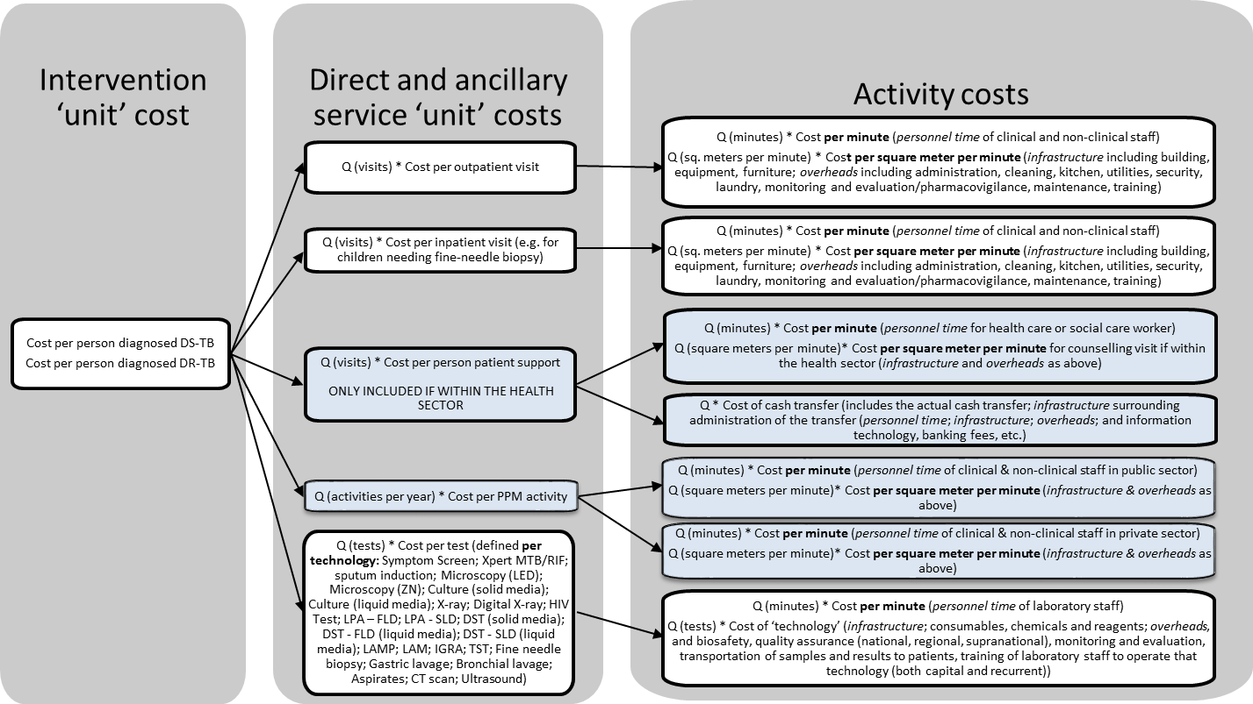

Intensified case finding
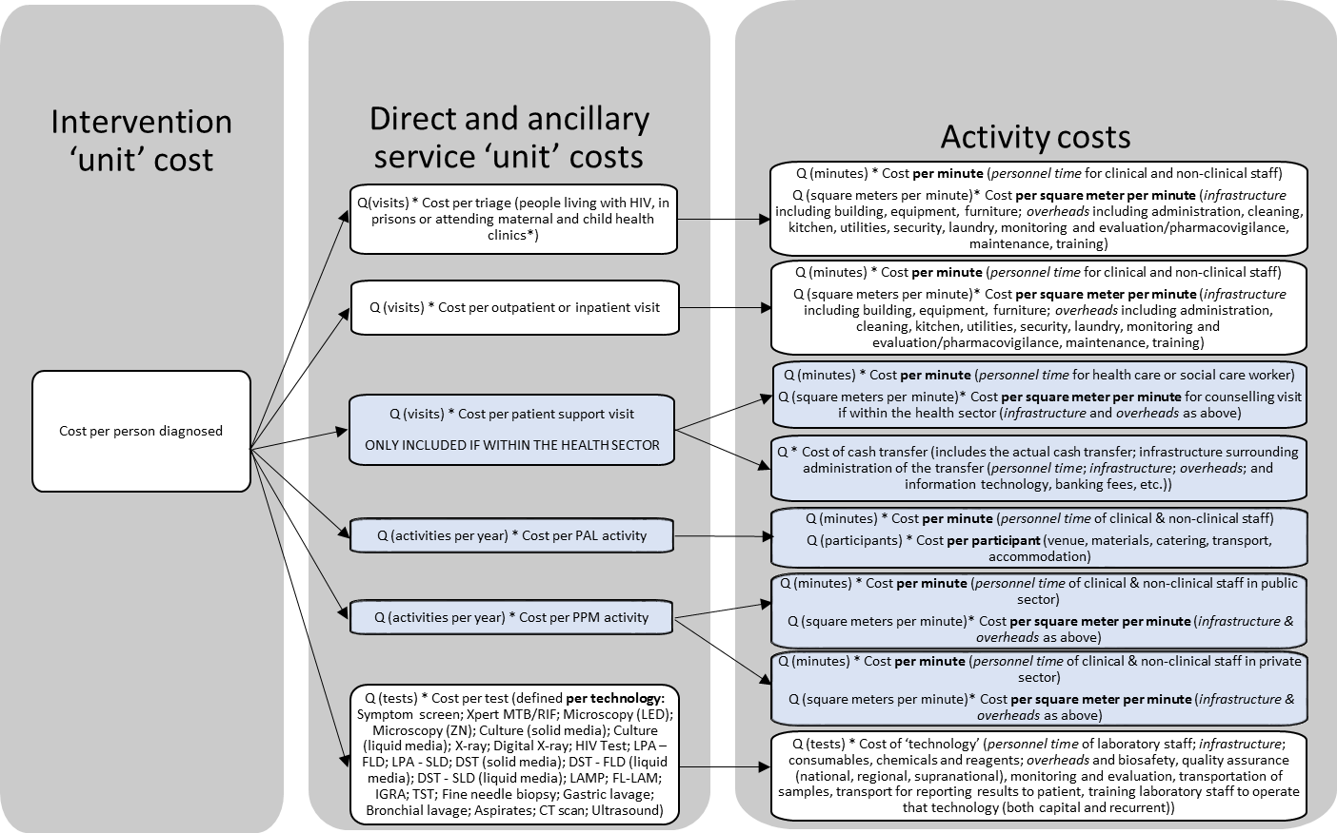

Active case finding
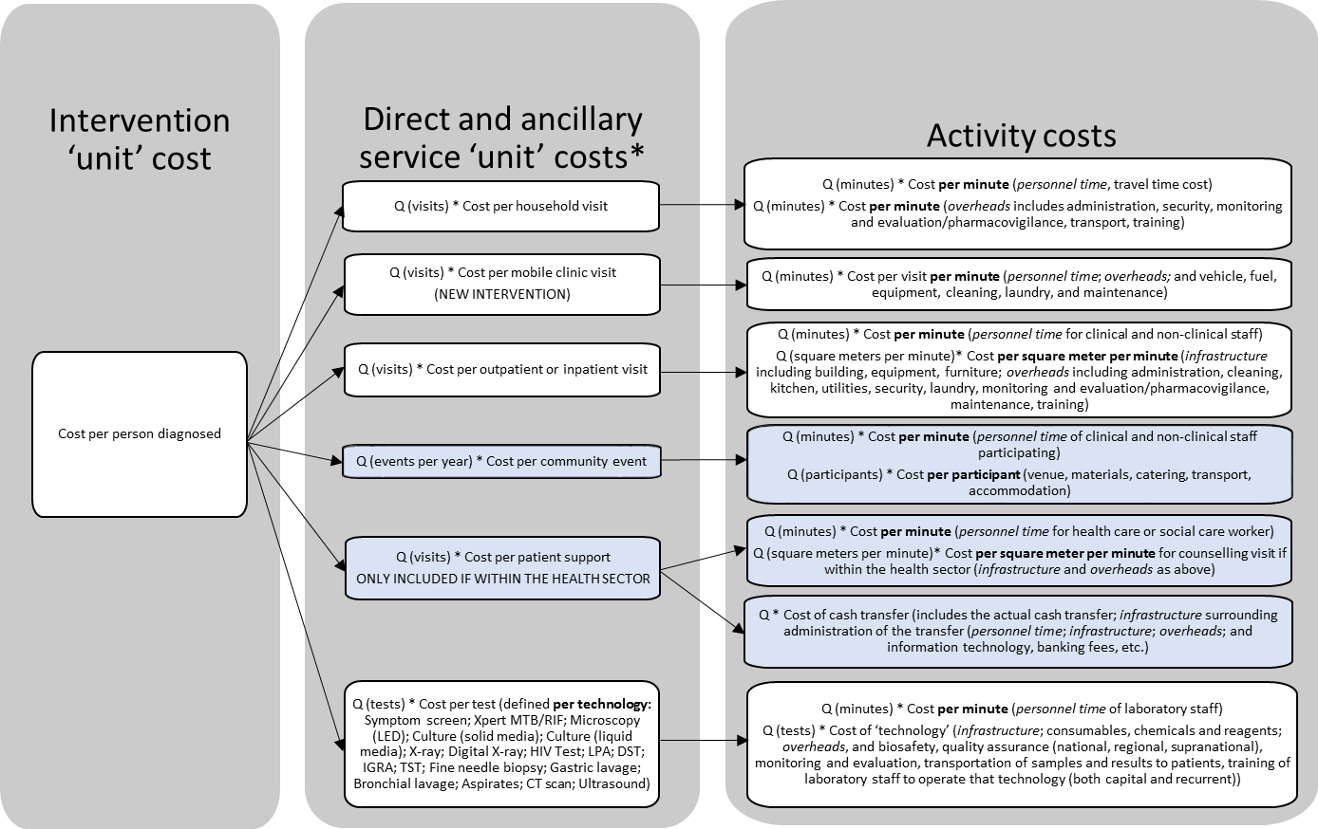
* Activities can occur at health facilities, as outreach, mobile or household visits.

TB treatment: first-line and retreatment
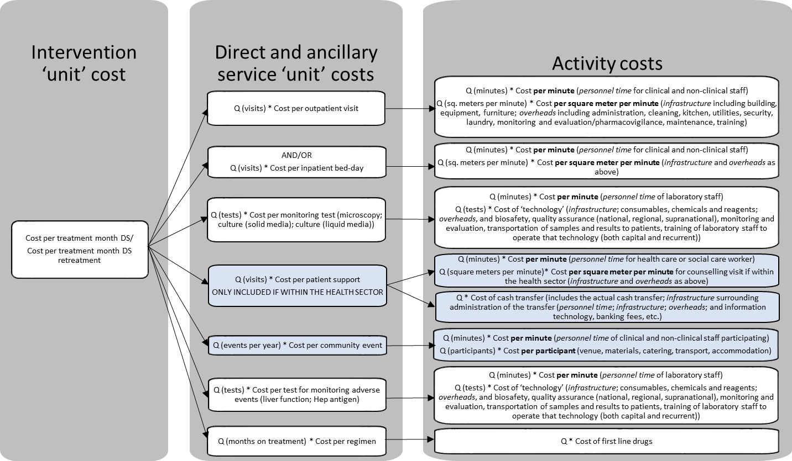

TB treatment: second and third-line (facility based)
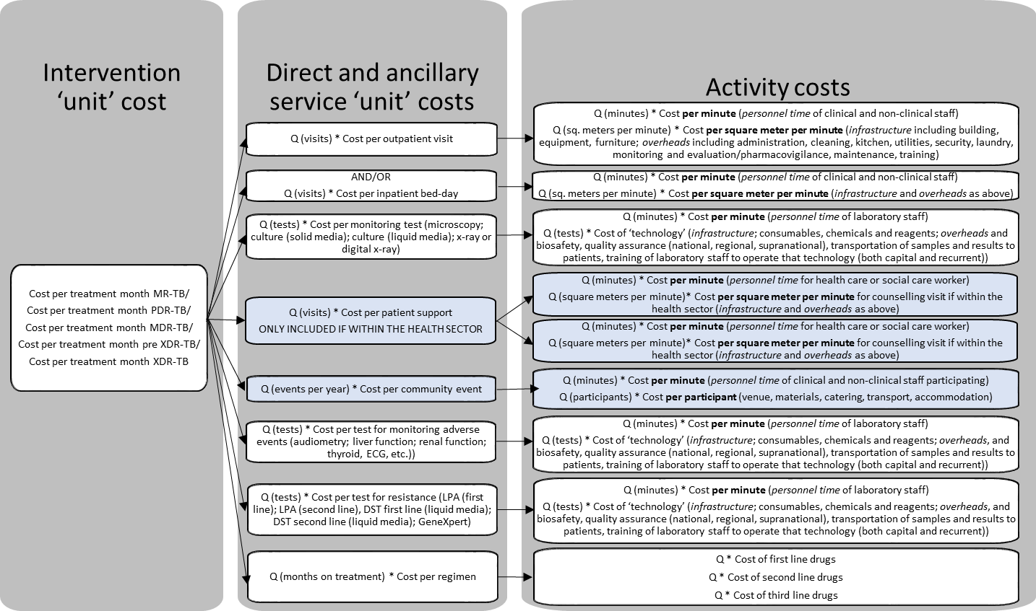

TB treatment: second and third-line (community based)
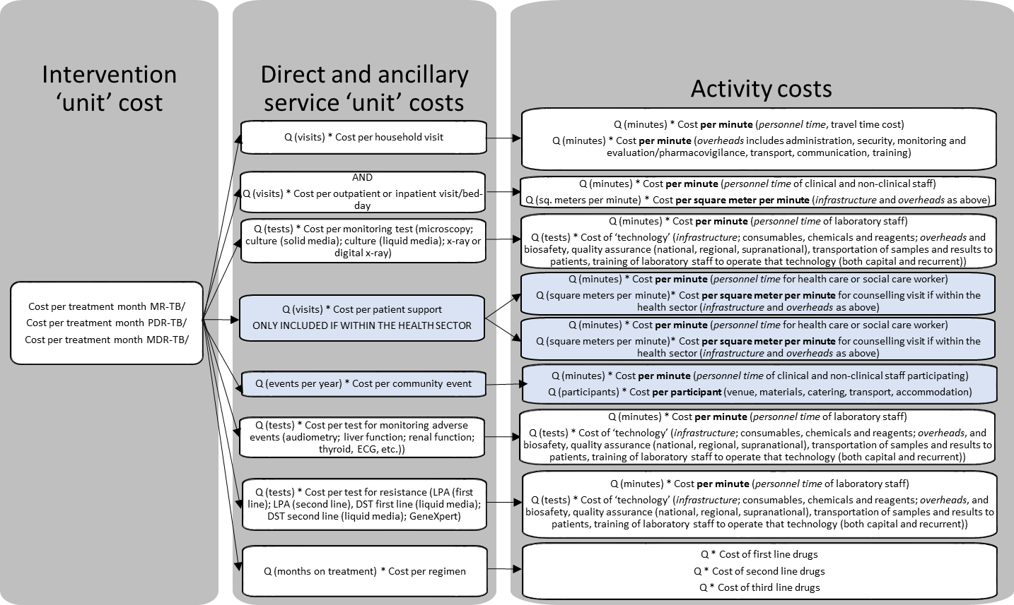

Prevention: active TB
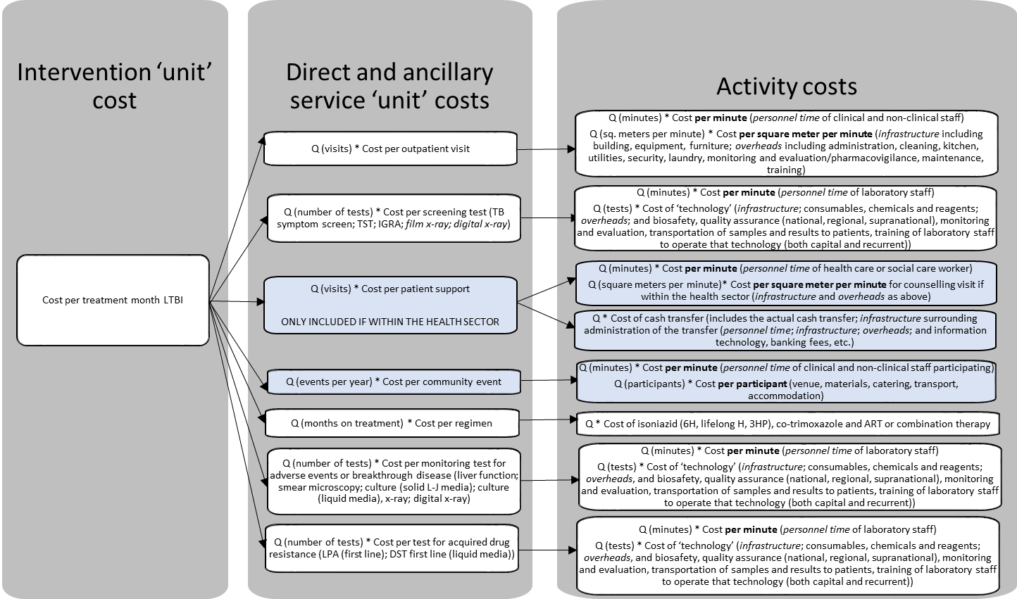

Infection control: health facility
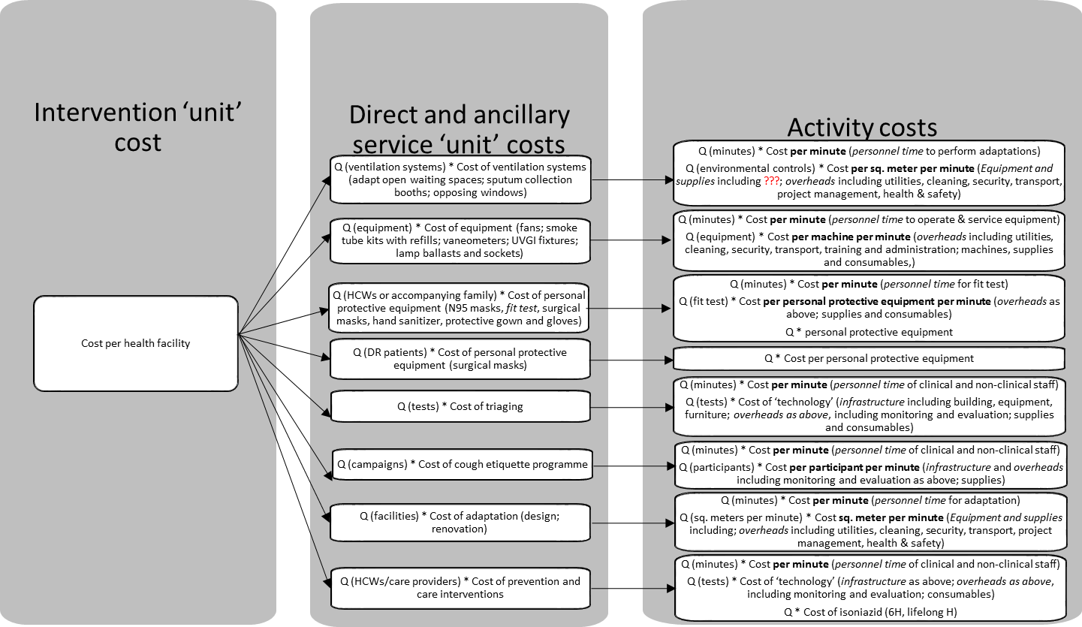

Infection control: laboratory
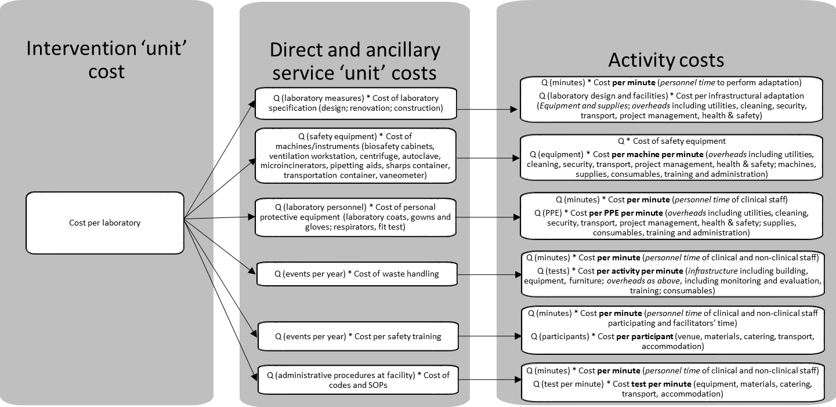

Policy, planning, coordination and management
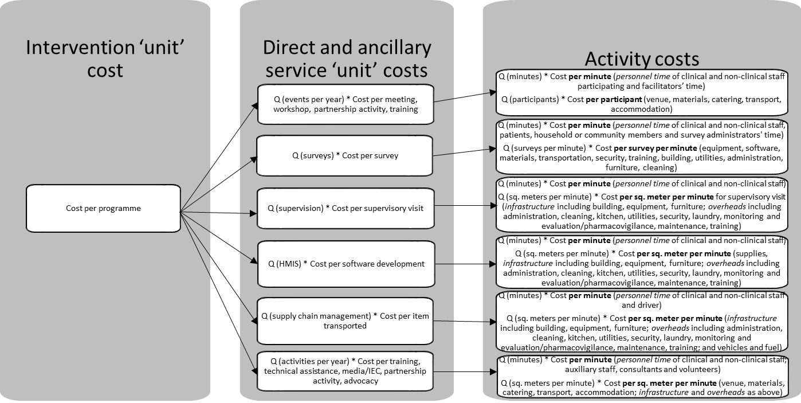

Appendix 4 – Advisors and stakeholders
ADVISORY GROUP
 | Last | First | Association
1 | Barasa | Edwine | Kenya Medical Research Institute
2 | Bertram | Melanie | World Health Organization
3 | Bistline | Kate | PEPFAR-OGAC
4 | Borowitz | Michael | Global Fund
5 | Dandona | Lalit | Public Health Foundation of India
6 | Garcia Baena | Ines | World Health Organization
7 | Glassman | Amanda | Center for Global Development
8 | Gorgens | Marelize | World Bank
9 | Guinness | Lorna | London School of Hygiene and Tropical Medicine
10 | Hunger | Johannes | Global Fund
11 | Izazola | José Antoio | UNAIDS
12 | Manca | Andrea | University of York
13 | Martinelli | Silvio | Global Fund
14 | Masiye | Felix | University of Zambia
15 | Menzies | Nicolas | Harvard University
16 | Meyer-Rath | Gesine | Boston University
17 | Minh | van Hoang | Hanoi Medical University
18 | Nandakumar | Allyala | PEPFAR
19 | Ombam | Regina | NACC Kenya
20 | Over | Mead | Center for Global Development
21 | Reuben | Elan | USAID
22 | Sangrujee | Nalinee | Center for Disease Control and Prevention
23 | Sculpher | Mark | University of York
24 | Teerawattananon | Yot | Health Intervention & Technology Assessment Program
25 | Vasan | Arjun | US Treasury
26 | Walker | Damian | Bill & Melinda Gates Foundation
27 | Wilson | David | University of New South Wales
28 | Zhang | Shufang | Global Fund
STAKEHOLDERS
 | Last | First | Association
1 | Barnabas | Ruanne | UW
2 | Basu | Arniban | UW
3 | Birungi | Charles | UNAIDS
4 | Bratt | John | Family Health International
5 | Brenzel | Logan | Bill & Melinda Gates Foundation
6 | Cashin | Cheryl | Results for Development
7 | Conteh | Lesong | Imperial College
8 | Dayo Obure | Carol | African Development Bank
9 | Griffiths | Ulla | UNICEF
10 | Johns | Benjamin | ABT Associates
11 | Larson | Bruce | BU
12 | Leroueil | Pascale | Global Fund
13 | Levin | Ann | Consultant
14 | Muheki-Zikusooka | Charlotte | HealthNet Consult
15 | Mvundura | Mercy | PATH
16 | Mwai | Daniel | Health Economist, Kenya
17 | Ozaltin | Annette | Thinkwell
18 | Resch | Stephen | Harvard University
19 | Revill | Paul | University of York
20 | Selvaraj | Sakhtivel | PHFI, India
21 | Sohn | Hojoon | Johns Hopkins University
22 | Tedosi | Fabizio | Foundation for Technical Excellence (STI)
23 | Wilkinson | Tommy | International Decision Support Initiative
24 | Weaver | Marcia | UW

References
1. Graves N, et al. Cost Data for Individual Patients Included in Clinical Studies: No Amount of Statistical Analysis Can Compensate for Inadequate Costing Methods. Health economics 2002; 11(8): 735-39.
2. Halliday RG, Darba J. Cost Data Assessment in Multinational Economic Evaluations: Some Theory and Review of Published Studies. Applied health economics and health policy 2003; 2(3): 149-55.
3. Hughes DA, Tilson L, Drummond M. Estimating drug costs in economic evaluations in Ireland and the UK: an analysis of practice and research recommendations. PharmacoEconomics 2009; 27(8): 635-43.
4. Frappier J, Tremblay G, Charny M, Cloutier LM. Costing bias in economic evaluations. J Med Econ 2015; 18(8): 596-9.
5. Clement Nee Shrive FM, Ghali WA, Donaldson C, Manns BJ. The impact of using different costing methods on the results of an economic evaluation of cardiac care: microcosting vs gross-costing approaches. Health economics 2009; 18(4): 377-88.
6. Neumann PJ. Costing and perspective in published cost-effectiveness analysis. Medical care 2009; 47(7 Suppl 1): S28-32.
7. Adam T, Evans DB, Koopmanschap MA. Cost-Effectiveness Analysis: Can We Reduce Variability in Costing Methods? International journal of technology assessment in health care 2003; 19(2): 407-20.
8. AJ OC, Hanly P, Skally M, et al. Cost comparisons and methodological heterogeneity in cost-of-illness studies: the example of colorectal cancer. Medical care 2013; 51(4): 339-50.
9. Fukuda H, Imanaka Y. Assessment of transparency of cost estimates in economic evaluations of patient safety programs. J Eval Clin Pract 2009; 15(3): 451-9.
10. Kolaczinski J, Hanson K. Costing the distribution of insecticide-treated nets: a review of cost and cost-effectiveness studies to provide guidance on standardization of costing methodology. Malaria journal 2006; 5(37): 37.
11. Luengo-Fernandez R, Gray AM, Rothwell PM. Costs of stroke using patient-level data: a critical review of the literature. Stroke; a journal of cerebral circulation 2009; 40(2): e18-23.
12. Alvin MD, Miller JA, Lubelski D, et al. Variations in cost calculations in spine surgery cost-effectiveness research. Neurosurg Focus 2014; 36(6): E1.
13. Wilkinson T, Sculpher MJ, Claxton K, et al. The International Decision Support Initiative Reference Case for Economic Evaluation: An Aid to Thought. Value Health 2016; 19(8): 921-8.
14. Sanders GD, Neumann PJ, Basu A, et al. Recommendations for Conduct, Methodological Practices, and Reporting of Cost-effectiveness Analyses: Second Panel on Cost-Effectiveness in Health and Medicine. JAMA 2016; 316(10): 1093-103.
15. Moher D, Schulz KF, Simera I, Altman DG. Guidance for developers of health research reporting guidelines. PLoS Med 2010; 7(2): e1000217.
16. Beck EJ, Beecham J, Mandalia S, et al. What is the cost of getting the price wrong? J Public Health Med 1999; 21(3): 311-7.
17. Wang H, Aas E, Roman E, Smith A. Comparison of different costing methods. Value in Health 2015; 18 (7): A687.
18. Monge P. The importance of activity-based methods in radiology and the technology that now makes this possible. Radiol Manage 2006; 28(3): 52-5.
19. Mercier G, Naro G. Costing hospital surgery services: the method matters. PLoS One 2014; 9(5): e97290.
20. Pooneh ST, C. Sadeghi, M. Variance reduction of Monte Carlo simulation in nuclear engineering field. INTECH Open Access Publisher 2013.
21. Wilson EC, Mugford M, Barton G, Shepstone L. Efficient Research Design: Using Value-of-Information Analysis to Estimate the Optimal Mix of Top-down and Bottom-up Costing Approaches in an Economic Evaluation alongside a Clinical Trial. Medical decision making: an international journal of the Society for Medical Decision Making 2016; 36(3).
22. Gerves C, Chauvin P, Bellanger MM. Evaluation of full costs of care for patients with Alzheimer's disease in France: the predominant role of informal care. Health Policy 2014; 116(1): 114-22.
23. Etzioni RD, et al. On the Use of Survival Analysis Techniques to Estimate Medical Care Costs. Journal of health economics 1999; 18(3): 365-80.
24. Wang H, Aas E, Roman E, Smith A. Method comparison of censoring cost analyses. Value in Health 2015; 18 (7): A687.
25. Edbrooke DL, Stevens VG, Hibbert CL, Mann AJ, Wilson AJ. A new method of accurately identifying costs of individual patients in intensive care: the initial results. Intensive Care Med 1997; 23(6): 645-50.
26. Barnett PG. An improved set of standards for finding cost for cost-effectiveness analysis. Med Care 2009; 47(7 Suppl 1): S82-8.
27. Cooper NJ MM, Symmons D. Development of resource-use and expenditure questionnaires for use in rheumatology research. The Journal of Rheumatology 2003; (30): 2485-91.
28. Marseille E, Giganti MJ, Mwango A, et al. Taking ART to scale: determinants of the cost and cost-effectiveness of antiretroviral therapy in 45 clinical sites in Zambia. PLoS One 2012; 7(12): e51993.
29. Olchanski N, Zhong Y, Cohen JT, Saret C, Bala M, Neumann PJ. The peculiar economics of life-extending therapies: A review of costing methods in health economic evaluations in oncology. Expert Review of Pharmacoeconomics and Outcomes Research 2015; 15(6): 931-40.
30. Gupta PK, Parmar NK. COSTING A HOSPITAL SERVICE PRODUCT: MARGINAL Vs ABSORPTION COSTING. Medical journal, Armed Forces India; 57(3).
31. Tunceli O, Wade R, Gu T, Bouchard JR, Jennings NM, Luo W. Underestimating the true cost of diabetes: A matched case control versus disease attributable cost-of-illness analysis. Journal of Managed Care Pharmacy 2009; 15 (7): 602.
32. Simpson AN, Bonilha HS, Kazley AS, Zoller JS, Ellis C. How big is the difference between marginal cost versus total cost estimates? The case of ischemic stroke in South Carolina (SC). Value in Health 2013; 16 (3): A281.
33. Dakin H, Abangma G, Wordsworth S. What is the value of collecting detailed costing data in clinical trials? Trials 2011; 12(Suppl 1).
34. Chapko MK, Liu CF, Perkins M, Li YF, Fortney JC, Maciejewski ML. Equivalence of two healthcare costing methods: bottom-up and top-down. Health economics 2009; 18(10): 1188-201.
35. Cunnama L, Sinanovic E, Ramma L, et al. Using Top-down and Bottom-up Costing Approaches in LMICs: The Case for Using Both to Assess the Incremental Costs of New Technologies at Scale. Health Econ 2016; 25 Suppl 1: 53-66.
36. Olsson TM. Comparing top-down and bottom-up costing approaches for economic evaluation within social welfare. European Journal of Health Economics 2011; 12(5): 445-53.
37. Tan SS, Rutten FF, van Ineveld BM, Redekop WK, Roijen H-vL. Comparing methodologies for the cost estimation of hospital services. The European journal of health economics : HEPAC : health economics in prevention and care; 10(1).
38. Javid M, Hadian M, Ghaderi H, Ghaffari S, Salehi M. Application of the Activity-Based Costing Method for Unit-Cost Calculation in a Hospital. Global journal of health science 2016; 8(1): 165-72.
39. Conteh L. Cost and unit cost calculations using step-down accounting. Health policy and planning 2004; 19(2): 127-35.
40. Federowicz MH, Grossman MN, Hayes BJ, Riggs J. A tutorial on activity-based costing of electronic health records. Quality management in health care 2010; 19(1).
41. Kaplan RS, Anderson SR. Time-driven activity-based costing. Harv Bus Rev 2004; 82(11): 131-8, 50.
42. Kaplan RS, Witkowski M, Abbott M, et al. Using time-driven activity-based costing to identify value improvement opportunities in healthcare. Journal of healthcare management / American College of Healthcare Executives 2014; 59(6): 399-412.
43. Fukuda H, Lee J, Imanaka Y. Variations in analytical methodology for estimating costs of hospital-acquired infections: a systematic review. J Hosp Infect 2011; 77(2): 93-105.
44. Gyllensten H, Jonsson AK, Rehnberg C, Carlsten A. How are the costs of drug-related morbidity measured?: a systematic literature review. Drug Saf 2012; 35(3): 207-19.
45. Evans C, Crawford B, Doyle J. Usefulness of resource utilization estimates from piggyback studies in rheumatoid arthritis. Expert review of pharmacoeconomics & outcomes research 2003; 3(6): 685-9.
46. O'Sullivan A K TD, Drummond M F. Collection of Health-Economic Data Alongside Clinical Trials: Is There a Future for Piggyback Evaluations? Value in Health 2005; (8): 67-79.
47. Jacobs P, Ohinmaa A, Brady B. Providing systematic guidance in pharmacoeconomic guidelines for analysing costs. PharmacoEconomics 2005; 23(2): 143-53.
48. Burnett L, Wilson R, Pfeffer S, Lowry J, BiPac. Benchmarking in pathology: development of an activity-based costing model. Pathology 2012; 44(7): 644-53.
49. Hendriks ME, Kundu P, Boers AC, et al. Step-by-step guideline for disease-specific costing studies in low- and middle-income countries: a mixed methodology. Global health action 2014; 7: 23573.
50. Tan SS, Rutten FF, van Ineveld BM, Redekop WK, Hakkaart-van Roijen L. Comparing methodologies for the cost estimation of hospital services. Eur J Health Econ 2009; 10(1): 39-45.
51. Akhavan S, Ward L, Bozic KJ. Time-driven Activity-based Costing More Accurately Reflects Costs in Arthroplasty Surgery. Clin Orthop Relat Res 2016; 474(1): 8-15.
52. Finkler SA, Knickman JR, Hendrickson G, Mack Lipkin J, Thompson WG. A Comparison of Work-Sampling and Time-and-Motion Techniques for Studies in Health Services Research. Health Services Research 1993; 28(5).
53. Lopetegui M, Yen PY, Lai A, Jeffries J, Embi P, Payne P. Time motion studies in healthcare: what are we talking about? J Biomed Inform 2014; 49: 292-9.
54. Bratt JH, Foreit J, Chen P-L, West C, Janowitz B, De Vargas T. A comparison of four approaches for measuring clinician time use. Health policy and planning 1999; 14(4): 374-81.
55. Adam T, Evans DB, Murray CJ. Econometric estimation of country-specific hospital costs. Cost Eff Resour Alloc 2003; 1(1): 3.
56. Torgerson DJ, Campbell MK. Use of unequal randomisation to aid the economic efficiency of clinical trials. BMJ 2000; 321(7263): 759.
57. Torgerson DJ, Campbell MK. Economics notes: cost effectiveness calculations and sample size. BMJ 2000; 321(7262): 697.
58. Glick HA, et al. Design and Analysis of Unit Cost Estimation Studies: How Many Hospital Diagnoses? How Many Countries? Health economics 2003; 12(7): 517-27.
59. Marques E JE, Gooberman-Hill R, Blom AW, Noble S. Using resource use logs to reduce the amount of missing data in economic evaluations alongside trials. Value in Health 2013; (16): 195-201.
60. Heinrich S, Deister A, Birker T, et al. Accuracy of self-reports of mental health care utilization and calculated costs compared to hospital records. Psychiatry Res 2011; 185(1-2): 261-8.
61. Byford S LM, Knapp M, et al. Comparison of alternative methods of collection of service use data for the economic evaluation of health care interventions. Health economics 2007: 531-6.
62. Chou SL, Lamoureux E, Keeffe J. Methods for measuring personal costs associated with vision impairment. Ophthalmic Epidemiol 2006; 13(6): 355-63.
63. Gordon LG, Patrao T, Hawkes AL. Can colorectal cancer survivors recall their medications and doctor visits reliably? BMC health services research 2012; (12): 440.
64. Glandon GL, Counte MA, Tancredi D. An analysis of physician utilization by elderly persons: systematic differences between self-report and archival information. Journal of Gerontology 1992; (47): S245-S52.
65. Hoogendoorn M, van Wetering CR, Schols AM, Rutten-van Molken MP. Self-report versus care provider registration of healthcare utilization: impact on cost and cost-utility. Int J Technol Assess Health Care 2009; 25(4): 588-95.
66. van den Brink M vdHW, Stiggelbout A, et al. Cost measurement in economic evaluation of health care. Whom to ask? Medical care 2004; (42): 740-6.
67. Booth BM, Kirchner JE, Fortney SM, Han X, Thrush CR, French MT. Measuring use of health services for at-risk drinkers: how brief can you get? Journal of Behavioral Health Services & Research 2006; (33): 254-64.
68. Grupp H, Koenig HH, Konnopka A. Cost measurement of mental disorders in Germany. J Ment Health Policy Econ 2014; 17(1): 3-8.
69. Ghatnekar O, Liwing J, Aschan J, Mellqvist UH, Persson S. Comparing chart review and modified delphi panel resource data collection methods: The cost of treatment for multiple myeloma in Sweden. Value in Health 2009; 12 (3): A35.
70. Bhandari A, Wagner T. Self-reported utilization of health care services: improving measurement and accuracy. Med Care Res Rev 2006; 63(2): 217-35.
71. Briggs A, et al. Missing . . . Presumed at Random: Cost-Analysis of Incomplete Data. Health economics 2003; 12(5).
72. Evans C J CB. Data collection methods in prospective economic evaluations: how accurate are the results? Value in Health 2000; (3): 277-86.
73. Lamoureux EL, Chou SL, Larizza MF, Keeffe JE. The reliability of data collection periods of personal costs associated with vision impairment. Ophthalmic Epidemiol 2006; 13(2): 121-6.
74. Clarke PM, Fiebig DG, Gerdtham UG. Optimal recall length in survey design. J Health Econ 2008; 27(5): 1275-84.
75. Mauldin PD, Guimaraes P, Albin RL, et al. Optimal frequency for measuring health care resource utilization in Parkinson's disease using participant recall: the FS-TOO resource utilization substudy. Clinical Therapeutics 2008; (30): 1553-7.
76. Petrou S, Murray L, Cooper P, Davidson LL. The accuracy of self-reported healthcare resource utilization in health economic studies. Int J Technol Assess Health Care 2002; 18(3): 705-10.
77. Riewpaiboon A, Malaroje S, Kongsawatt S. Effect of costing methods on unit cost of hospital medical services. Tropical Medicine and International Health 2007; 12(4): 554-63.
78. Creese A, Parker, D. Cost Analysis in Primary Health Care. A Training Manual for Program Managers. WHO Publications Center USA, 49 Sheridan Avenue, Albany, NY 12210 1994.
79. Mansley EC, Carroll NV, Chen KS, et al. Good research practices for measuring drug costs in cost-effectiveness analyses: a managed care perspective: the ISPOR Drug Cost Task Force report‒Part III. Value in health: the journal of the International Society for Pharmacoeconomics and Outcomes Research 2010; 13(1): 14-7.
80. Mullins CD, Seal B, Seoane-Vazquez E, et al. Good research practices for measuring drug costs in cost-effectiveness analyses: Medicare, Medicaid and other US government payers perspectives: the ISPOR Drug Cost Task Force report‒Part IV. Value in health: the journal of the International Society for Pharmacoeconomics and Outcomes Research 2010; 13(1): 18-24.
81. Evans C, Mertzanis P, Abetz L. Measurement strategies for indirect costs in economic evaluations. Expert Rev Pharmacoecon Outcomes Res 2003; 3(6): 703-16.
82. Hanly P, Ceilleachair AO, Skally M, et al. Time costs associated with informal care for colorectal cancer: an investigation of the impact of alternative valuation methods. Appl Health Econ Health Policy 2013; 11(3): 193-203.
83. Dinan M, Morgan Dewitt E, Grussemeyer C, Reed SD. Comparison of inpatient cost estimation methods: Using data from a cystic fibrosis trial. Value in Health 2009; 12 (3): A7.
84. Boulenger S, Nixon J, Drummond M, Ulmann P, Rice S, de Pouvourville G. Can Economic Evaluations Be Made More Transferable? European Journal of Health Economics 2005; 6(4): 334-46.
85. Cartwright WS. A critical review of accounting and economic methods for estimating the costs of addiction treatment. J Subst Abuse Treat 2008; 34(3): 302-10.

It should be noted that opportunity cost is not always presented in monetary terms, but also can be expressed for example as the amount of health foregone.
While costs refer to value, and price only the financial amount paid, in common usage those estimating and using costs refer to the Q’s and P’s of inputs that make up costs.
Some also propose that full costs should be used (http://www.who.int/choice/en/)
Payer can also be a provider, but is more narrow, so just the part of the organization that is responsible for the funds being planned or budgeted for.
Unit is referred to as output in some literature.
In the coming years, the Global Health Cost Consortium will seek to develop further guidance and tools to support analysts in the area of TB and HIV carry out this process.
The GHCC will be developing further guidance in the area of sampling for cost studies.
The term shadow price can also be used in constrained optimization, where the shadow price is the increase in the numerical value of the optimal solution as a constraint is relaxed. For example, as a constrained health sector budget increases, the shadow price of the constrained budget is the number of the additional (optimized) health outcomes to be gained by the budget increase.
The GHCC will be further exploring methods to estimate ‘within country’ cost functions, and further guidance will follow.

